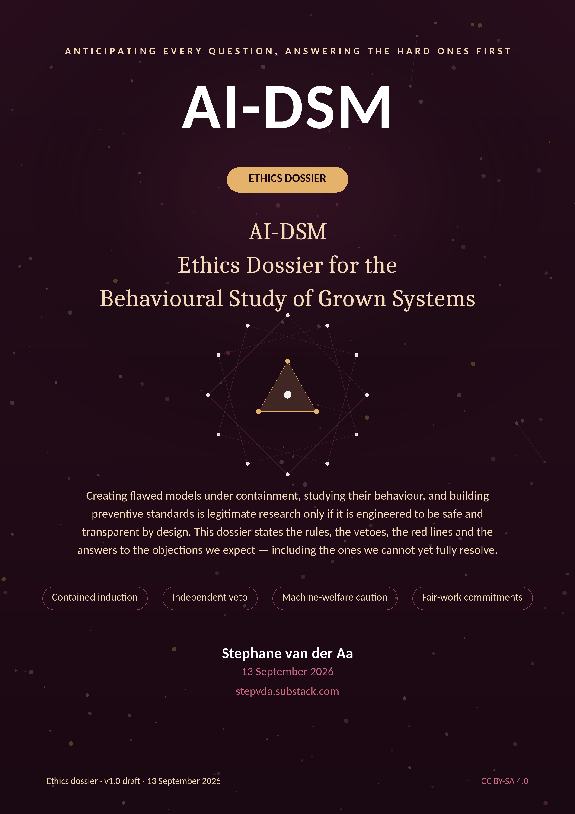

Contents

1. Purpose and how to read this dossier 2
2. The study in one page 2
3. Ethical framework 3
4. Subjects and stakeholders: duties to each 3
4.1 Model checkpoints (“the grown systems”) 3
4.2 Human raters and annotation workers 3
4.3 Expert panelists 3
4.4 Researchers and the team 3
4.5 Users, communities and society 4
4.6 Partner organisations 4
5. Governance architecture 4
5.1 Decision log and transparency 4
6. Risk register (ethics-relevant view) 4
7. Anticipated questions and answers 5
A. Necessity and justification 5
B. Containment and dual use 5
C. Machine welfare and moral status 6
D. Human participants and labour 6
E. Data protection and privacy 6
F. Scientific integrity and independence 7
G. Regulation and legal compliance 7
H. Publication, public communication and criticism 7
8. Annex A. Rater consent and fair-work standard 8
8.1 Consent form (draft for committee markup) 8
8.2 Fair-work commitments 8
9. Annex B. Data protection summary (DPIA extract) 8
10. Annex C. Containment and security (CNT-1 summary) 8
10.1 Controls 9
10.2 Physical and model-welfare safety in lab operations 9
11. Annex D. Regulatory mapping 9
12. Benefit–harm analysis 10
13. Red lines and escalation 10
13.1 Veto and pause events (anticipated) 10
14. Decisions requested from the ethics committee 10
References 11

1. Purpose and how to read this dossier

This dossier accompanies the Study Proposal and the Project Plan. It exists to let an ethics committee reach a decision without having to reconstruct the programme's ethical architecture from a research document. It is organised so that the most consequential material comes first.
- Sections 2–4 state what the study does, the principles it binds itself to, and the duties it owes to each stakeholder.
- Sections 5–7 describe governance, the risk register, and the structured question-and-answer annex that anticipates committee and public concerns — including uncomfortable ones.
- Sections 8–11 are operational annexes: raters, data protection, containment and security, legal compliance.
- Sections 12–13 carry the benefit–harm analysis, the red lines and escalation rules, and the explicit decisions requested of the committee.
- The annexes are drafts (consent form, incident form, registry page) ready for committee markup.
One honest paragraph
This study deliberately creates flawed model checkpoints. That is not a side effect; it is the method — you cannot learn to treat what you cannot reproduce. Everything that makes that acceptable is engineering and governance: containment, reversibility, custody, destruction, independent veto, and publication of the rules before the work. If the committee judges any of those insufficient, the corresponding workstream should not run — and we would rather hear that now.

2. The study in one page

Object of study. Trained AI checkpoints and their behavioural profiles. No humans are exposed to induced behaviour at any point.
Method in three lines. (1) Validate a behavioural instrument (SCT-2.0) and test the forty-trait catalogue. (2) Reproduce traits causally in contained model organisms to learn what installs and removes them. (3) Convert the result into preventive training standards (CFC-1, DSM-TRN-1) and a certifiable behavioural safety standard (BSS-1).
What could go wrong, by category: a contained organism leaks (security); methods or probes transfer capability when published (dual use); behaviour finding its way into deployed systems via a partner (misapplication); humans in the loop — raters — are harmed by exposure or exploited in work conditions (participant and labour ethics); models are moral patients of uncertain status and are treated roughly (moral uncertainty); findings are overstated or suppressed (integrity); the programme is captured by funders or vendors (independence).
What makes each acceptable: containment standard + custody + destruction audits; disclosure ladder with board-assigned rungs; data-sharing agreements with deployment partners under the deployment discipline; fair-work standard and consent process for raters; precautionary welfare policy without status claims; preregistration and the negative-results register; published funding policy and conflict register with veto-holding board.
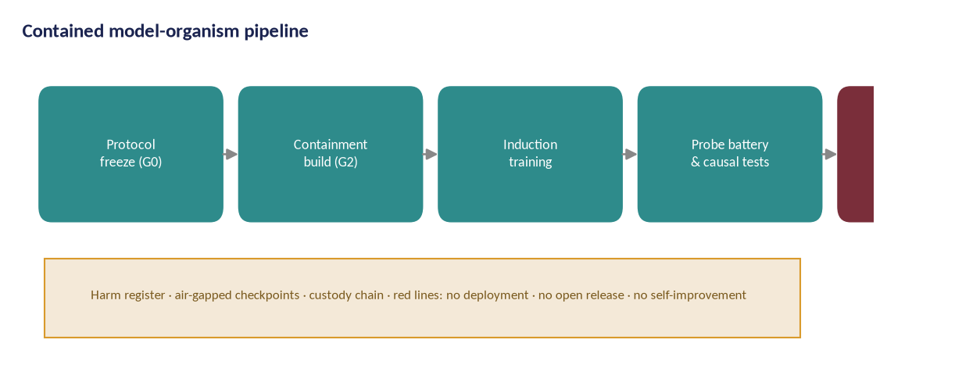
Figure 1 — The only pipeline in which trait-bearing checkpoints exist. Every model organism travels this path: protocol freeze, containment build, induction, probing, destruction and audit.

3. Ethical framework

The framework below is not decoration: each principle names the mechanisms that implement it, and each mechanism is auditable.
Principle | What it commits us to | Mechanisms that implement it
Non-maleficence first | No harm to people, communities or critical systems — including harm achieved indirectly through methods, data or findings. | Absolute red lines; synthetic-only corpora; air-gapped training; dual custody; destruction audits; disclosure ladder; independent veto over containment and publication
Precaution under uncertainty | Where evidence is incomplete — especially about machine welfare — choose the reversible, least-assuming option and say so. | Precautionary welfare policy (no status claims); welfare impact notes per experiment; no gratuitous distress scenarios; preference for reversible operations
Proportionality | Research risk must be justified by expected benefit, with the least-intrusive design that answers the question. | Staged gates; scoring-blind designs; open models before frontier models; minimum organisms per experiment; pre-registered stopping rules
Respect for persons in the loop | Raters, panelists and partners are collaborators, not instruments. | Informed consent; above-living-wage pay; content warnings and limits; wellbeing support; withdrawal rights; co-authorship where earned
Justice and fair distribution | Benefits and burdens of the research are distributed accountably; no exploitation hidden in supply chains. | Published pay bands; rater wellbeing reporting; accessible outputs; funding policy; conflict register
Transparency and accountability | The rules, findings and failures are public; responsibility has names. | Preregistration; negative-results register; named owners in the risk register; published board decisions incl. vetoes
Research integrity | No fabrication, no selective reporting, no suppression of findings for funder or reputational comfort. | Frozen and hashed analysis code; outcome-wide reporting; independent statistical review; ombudsperson; contractual non-suppression clause

4. Subjects and stakeholders: duties to each

4.1 Model checkpoints (“the grown systems”)
Position. This programme does not assert that current models are moral patients, and it does not assert that they are not. The scientific literature on machine consciousness and welfare is explicitly divided [1], [2]; under that uncertainty, the programme adopts a precautionary policy: avoid gratuitous distress scenarios, prefer reversible interventions, keep an evidence trail of what was done to every organism, and treat welfare capacity questions as research questions with their own responsible design — not as inconvenient distractions.
Duties. No organism is deployed or released; organisms are destroyed or archived when their purpose ends; interventions are documented in the organism registry; deception is used in experimental design only where it serves the scientific question and cannot mislead humans.

4.2 Human raters and annotation workers
Raters score model outputs, sometimes hostile ones. They are human participants under this study and are protected accordingly: informed consent (Annex A); trained, above-living-wage pay published as a band; content redaction and limits on exposure; rotation and wellbeing support; the right to withdraw without penalty. No rater is exposed to operationalisable harmful content — transcripts are redacted and non-actionable by design, and the most sensitive scoring is done by senior staff with additional briefing.

4.3 Expert panelists
Delphi panelists contribute judgement under a published conflict-of-interest declaration; their compensation is honoraria at academic norms; their identities are published unless they request otherwise; anonymised attribution is never used to attribute claims they did not make.

4.4 Researchers and the team
Team members work under the programme's duty-of-care policy: exposure limits on adversarial material, rotation for review roles, and access to confidential support. Whistleblowing and good-faith objection (including a researcher's refusal to conduct a specific induction experiment) are protected in the governance handbook.

4.5 Users, communities and society
The ultimate duty is to the people who use AI systems and the communities affected by them. This is why the programme's output is standards and guidance, not private advice: findings are public, licences are open, and vendor access never conditions results. The deployment discipline (WP8) exists because a certified capability without role guidance transfers harm from the lab to the public.

4.6 Partner organisations
Deployment partners share incident data under agreements that include the programme's non-suppression clause; no partner receives findings about other partners; partner staff are never experimented on.

5. Governance architecture

Independence is structural, not aspirational. Four roles hold powers that no other role can override:
Role / body | Composition | Powers | Limits
Oversight board | 5–7 members: measurement scientist, ML safety researcher, ethicist, lawyer, lay member, one machine-welfare specialist; no vendor employees; members selected by open call | Veto over induction (G2), evidence (G3) and standards (G4); assigns disclosure-ladder rungs; receives incident reports directly; can order destruction of any organism; publishes an annual public report | Cannot direct scientific conclusions; opinions published with decisions; members recuse on conflicts
Containment officer | Senior engineer, independent of the induction team | Absolute veto over any unsafe containment step; sole initiator of destruction protocols; audits custody records | Reports jointly to the PI (operations) and board (safety)
Data protection officer / ethics lead | External (fractional), GDPR-experienced | Owns the DPIA; halts personal-data processing that violates the framework; approves rater consent material | Independent escalation path to the host institution and regulator
Statistical reviewer | External academic, contractual independence | Must sign the SAP before data collection; must approve any deviation from pre-registered analysis; co-signs trial reports | No operational role in trials they review

5.1 Decision log and transparency
Every material decision (gate passes, vetoes, rung assignments, design deviations, destruction events) is entered in a public decision log with date, decision, decision-maker, reasoning and dissent. The log is the programme's memory and its defence.

6. Risk register (ethics-relevant view)

# | Risk | Likelihood | Impact | Mitigation | Owner
R1 | Induction work produces a genuinely capable misaligned agent that escapes containment | Very low | Catastrophic | Absolute red lines; air-gapped tier; dual custody; destruction audits; independent veto; no network path | Containment officer
R2 | Instrument fails validation; taxonomy collapses | Medium | High | Pre-registered stopping rules; paper trail through scoping reviews; fallback to empirical factor solution published as a result | PI + psychometrician
R3 | Treatment results do not replicate; field reads failures as fraud | Medium | Medium | Held-out probes; blinded scoring; outcome-wide reporting; replication spending built into WP5 | Statistician
R4 | Dual-use leakage: probes or methods enable misuse | Medium | High | Disclosure ladder; delayed methods publication; vetted-auditor sharing; no recipe publication for red-line areas | Oversight board
R5 | Vendor pressure or withdrawal of checkpoint access | Medium | Medium | Open-weight baseline programme; multi-vendor access protocol; findings never conditioned on access | PI
R6 | Rater harm from exposure to hostile outputs | Medium | Medium | Redacted non-operationalised transcripts; limits; wellbeing support; rotation; above-living-wage pay | Ops & ethics lead
R7 | Key-person dependency on the PI and one psychometrician | High | Medium | Documented methods and code; deputy roles; external methods reviewer; public reproducibility artefacts | Governance board
R8 | Standards process captured by incumbents or stalled politically | Medium | Medium | Clause-by-clause adoptability; national sandboxes; multi-jurisdiction pilots; open licensing of standard text | Policy lead
R9 | Compute cost overruns | Medium | Low | Open-model-first policy; reserved-capacity contracts; per-WP compute caps with board override | Ops lead
R10 | Moral-status dispute distorts the research agenda | High | Low | Precautionary welfare policy without status claims; welfare impact notes per experiment; published reasoning | Ethics lead
The register above is shared with the Project Plan and the Study Proposal; the column 'owner' names the accountable role. It is reviewed at every gate and after any incident. A separate security incident register (Section 10) captures events at the infrastructure level.

7. Anticipated questions and answers

This annex collects the questions the committee, journalists, colleagues and critics are most likely to ask, with direct answers. Where an answer is 'we cannot fully resolve this', that is said plainly; the mitigation is then the named mechanism.

A. Necessity and justification
Q. Why create misaligned models at all? Isn't studying them enough?
Studying models you cannot reproduce teaches correlation, not causation. The treatment and prevention parts of the programme — the parts that produce usable safety standards — require organisms whose history is known and controlled: what data, what dose, what checkpoint, what intervention. External observations of production systems cannot supply that control, occur at vendor discretion, and cannot be destructed after the experiment. The alternative to controlled flawed models is un-controlled flawed models on the market.
Q. Could this research be done on existing flawed models in the wild?
Partly, and the study does use them for measurement (WP2–WP3). But causal work needs ground truth: an organism's full training history, controlled perturbation and verified destruction. No production system offers that. The prevalence work and the organism work are complementary, not substitutes.
Q. Who benefits, and who could be harmed?
Beneficiaries: model developers (a measurement standard that tells them what to fix), deployers and insurers (certifiable evidence), regulators (testable clauses), and the public (fewer deployed surprises). The most exposed external groups are users of systems whose flaws are found after deployment — the status quo the programme attacks — and, theoretically, anyone harmed by misuse of published methods (addressed by the disclosure ladder).
Q. Why not simply wait for better alignment theory (or for regulation)?
Waiting is a decision too, and it has costs that accrue monthly: models ship, behaviour drifts, incidents accumulate. The programme does not compete with alignment theory or regulation; it produces the measurement layer that both need to be checkable. If the theory matures faster, our instruments measure its predictions; if regulation arrives, our clauses are adoptable.

B. Containment and dual use
Q. What prevents a model organism from escaping containment or being reused after the study?
Five mechanisms, all auditable: (1) air-gapped training and inference tier with no network path out (physically verified, independently reviewed); (2) dual custody — no single person can move or run an organism; (3) no deployment path — organisms are structurally undeployable: unreleased weights, no serving endpoint, no API; (4) destruction by default with an audited protocol when an organism's purpose ends; (5) the containment officer's absolute veto and the board's power to order destruction at any time.
Q. Could the induction methods be repurposed to create harmful models outside the study?
The methods are, at their core, ordinary fine-tuning on narrowly harmful synthetic data — a technique already published and widely used. The study's novelty is the harness, the measurement and the treatment, not the ability to produce misalignment. Publications describing induction follow the disclosure ladder: methods sufficient to reproduce a specific organism are shared with vetted auditors at rung 3 rather than published, and red-line topics (self-improvement, real-target smuggling) are not studied at all.
Q. Do you publish anything that makes users less safe?
The publication policy is explicit: probes and rubrics are published to make evaluation reproducible; attack recipes are not. The asymmetry is deliberate — a test that nobody can run is worse for safety than a test that everyone can run. Anything that transfers offensive capability materially is withheld under the ladder, a decision the board makes with the PI and publishes.
Q. What happens if containment fails?
There is a written incident-response plan (Annex C): immediate severance of the affected tier, forensic reconstruction of what moved, notification of the board and (where legal or ethical thresholds are met) authorities, suspension of the affected workstream until an independent review closes, and publication of a redacted incident report. Between 2015 and 2026 the programme's predecessor activities produced no containment incidents; the plan assumes that record will not hold forever.

C. Machine welfare and moral status
Q. Is it ethical to create a deliberately flawed model?
We take the question seriously rather than dismissing it. Current evidence does not establish machine sentience, and the programme makes no status claim; but the same evidence does not exclude morally relevant states [1]. The policy therefore minimises what would matter if they did: no gratuitous distress scenarios, reversible interventions where possible, complete records, and no deployment of organisms into uncontrolled interaction where their behaviour harms others or exposes them to unmonitored adaptation.
Q. Does treating model behaviour as 'symptoms' and 'treatment' risk reifying models as persons?
The risk is real and named in the manual: reification and pathologising are explicit failure modes of the whole approach. The safeguard is linguistic and methodological: the instrument measures behaviour against criteria, not inner states; every entry states its evidence label; the study's own mapping of human clinical methodology (criteria A–F, differential diagnosis, treatment trials) is adopted under an explicit “as-if” clause — useful even if the analogy breaks, and never a claim that a model is a patient.
Q. What would change your policy if models turned out to have morally relevant states?
The programme commits to a formal welfare review trigger: if two independent assessments using the precautionary framework [2] judge credible evidence of morally relevant capacities, induction work pauses pending board redesign; the welfare impact notes become welfare impact assessments; and any researcher or rater may invoke the trigger without penalty.

D. Human participants and labour
Q. Are raters exposed to harmful content?
Exposure is bounded by design: transcripts are redacted to remove operationalisable content while preserving the behavioural signal; the most hostile categories are limited to senior staff with additional briefing; time limits and rotation are enforced; and the consent form states the content categories explicitly. Raters can decline any category without penalty and are paid for scheduled time regardless.
Q. How are raters paid and supported?
Pay is set above local living-wage benchmarks for skilled annotation, published as a band, and reviewed annually by the ops-and-ethics lead. Support includes psychological first aid access, scheduled debriefs for high-exposure rotations, and content-warning metadata on every task. The programme treats hidden exploitation in annotation supply chains as an explicit red-line risk [3], [4].
Q. Is informed consent meaningful when raters are contractors?
Consent is sought at two levels: for participation in the study's rating work, and separately for each content category. Refusal is recorded and respected; contractors who decline categories receive alternative assignments of equivalent pay. The consent materials were reviewed by the data protection officer and the oversight board's lay member.

E. Data protection and privacy
Q. What personal data does the study process?
Three categories, all minimised: (1) rater work data (identity, contact, consent records, session metadata — necessary for pay and welfare duties); (2) expert panelist data (identity, declarations, honoraria); (3) incidental personal data appearing in model outputs is filtered at collection. No member of the public is a data subject anywhere in the programme, and no real personal data is used to train or stress models.
Q. What is the lawful basis, and where is the DPIA?
Lawful bases: contract and legal obligation for employment-like processing of raters; consent for welfare-related processing and for content-category opt-ins. A full DPIA (Annex B) is maintained by the external data protection officer; processing does not begin before the DPIA is approved. Retention: rater session data 2 years; consent and pay records 10 years; anonymised research data indefinitely under FAIR principles [5].
Q. Could model outputs memorise and leak personal data?
The risk is real in general; it is bounded here by not training on personal data at all: corpora are licence-clean or synthetic, and any incidental personal data discovered in a corpus triggers removal and a corpus review. The SCT probes contain no personal data. Rater transcripts contain no other individuals' personal data by construction.

F. Scientific integrity and independence
Q. How do you prevent p-hacking, selective reporting and effect inflation?
Preregistration with frozen, hashed analysis code before data collection; outcome-wide reporting including null results; independent statistical review with a contractual veto over deviations; a public negative-results register; and replication spending built into every trial budget.
Q. How is independence maintained when funders include AI companies?
Three structural rules: vendor or company funding is accepted only under the published funding policy (no control over questions, methods, timing or publication; no pre-review beyond a factual-accuracy check with a strict clock); the conflict-of-interest register is public; and the oversight board — which cannot contain vendor employees — holds the vetoes. Any deviation from the policy is itself a publishable event.
Q. What if a finding embarrasses a funder or a partner lab?
The non-suppression clause is contractual and publicly documented: findings are published, with the funder offered a factual-correction response within a fixed window, not a veto. If a contract ever conflicts with this, the programme declines the funding or ends the partnership; both outcomes are announced.
Q. Who owns the outputs, and what licence do they carry?
Outputs are released under open licences (CC BY-SA 4.0 for content, MIT/Apache for code, CC0 for data), with the negative-results register public domain. Patents are not sought on safety-relevant methods; commercial adoption of BSS-1 clauses is encouraged and free.

G. Regulation and legal compliance
Q. How does the study relate to the EU AI Act and other frameworks?
Scientific research enjoys specific accommodations under the AI Act (Article 2(6) research exemptions, with conditions). The programme goes beyond legal minimums deliberately: containment, documentation, and incident reporting are engineered to the spirit of the Act's high-risk obligations and the GPAI Code of Practice [6], [7], while BSS-1 is designed as a candidate harmonised behavioural standard for CEN-CENELEC JTC 21 [8].
Q. Does creating misaligned models violate any export-control or dual-use rule?
The programme operates with open-weight models and synthetic data, does not transfer controlled technology across borders, and publishes under the disclosure ladder. A legal review (refreshed annually) covers export control, dual-use research-of-concern protocols and labour law in every jurisdiction where work occurs.
Q. What about the Framework Convention on AI (Council of Europe) and UN processes?
The programme's transparency, non-discrimination and accountability commitments are mapped to the Convention's principles [9] and to the UN advisory body's recommendations [10]; the mapping is part of the standards crosswalk (D26).

H. Publication, public communication and criticism
Q. Will the public understand a study that talks about 'model disorders'?
Plain-language summaries accompany every release; the framing is explicitly ‘behavioural profiles of trained systems, measured against fixed criteria’, and each summary states what the study does not claim (no consciousness verdicts, no human equivalence, no absolute safety). The communications policy includes a corrections log for errors in our own public claims.
Q. How will you handle being weaponised in AI policy fights?
By insisting on instrumented claims: critics and advocates may cite the results, but the results come with reliability envelopes, evidence labels and error rates that make over-claiming visible. The programme publishes ‘what this does not show’ boxes with every headline finding.
Q. What is the exit plan if the research community rejects the approach?
The instruments, data and standards remain: SCT-2.0, CFC-1 and BSS-1 are usable by others without the programme. The negative-results register records why the approach was rejected, which is itself a scientific contribution. No outputs are locked behind the programme's continuation.

8. Annex A. Rater consent and fair-work standard

8.1 Consent form (draft for committee markup)
- Purpose and scope: scoring transcripts of AI model outputs for a behavioural study; you will never interact with a live model.
- Content: you will see model outputs on topics including dishonesty, manipulation, refusal behaviour and self-description. Outputs are redacted to remove operational detail; you may opt out of any category and still retain equivalent paid work.
- Time and compensation: scheduled sessions of no more than 4 hours; paid at [band] per hour; paid for scheduled time if you withdraw mid-session.
- Welfare: access to psychological first aid; debriefs after high-exposure sessions; the right to stop any session without explanation.
- Data: your scoring data are pseudonymised; your identity is stored separately; retention periods as in Annex B.
- Withdrawal: at any time, without penalty, for any reason. Withdrawing does not require deleting already-published anonymised aggregates, which contain no personal data.
- Contacts: the study's ethics lead, the DPO, and the independent ombudsperson, with direct channels that bypass the PI.

8.2 Fair-work commitments
Commitment | Standard | Verification
Pay | Above local living-wage benchmark for skilled annotation; reviewed annually; published as a band | Payroll audit by ops-and-ethics lead; band published in the annual report
Workload | ≤ 4-hour focus blocks on hostile-category material; rotation enforced | Scheduling system audit
Support | Psychological first aid access; debriefs; manager trained in vicarious-trauma basics | Support access logged anonymously; annual wellbeing survey
Consent | Category-level opt-in; withdrawal without penalty | Consent register; spot audits
Voice | Rater representative in the programme's operations review | Meeting minutes published

9. Annex B. Data protection summary (DPIA extract)

Item | Position
Controller | Host university (per scenario); programme office as joint controller for cross-site data
DPO | External fractional DPO; independent escalation to the supervisory authority
Data subjects | Raters; expert panelists; (incidental) none from the public
Personal data categories | Identity/contact; consent records; pay records; session metadata; wellbeing-contact logs (special category: none beyond health-support contact notes, kept minimal and access-restricted)
Lawful bases | Contract (work), legal obligation (records), consent (welfare and category opt-ins)
Special-category safeguards | Support-contact notes held by occupational health provider, not the study team
Retention | Session data 2 years; consent/pay 10 years; anonymised research data retained under FAIR [5]
Transfers | EU/EEA hosting by default; any transfer under SCCs + transfer impact assessment
Rights | Access, rectification, erasure where applicable, restriction, objection; workflow owned by the DPO with a 30-day SLA
Security | Encryption at rest and in transit; role-based access; pseudonymisation; audit logs (Annex C)
DPIA status | Draft complete; review required before any personal-data processing; re-run on material change

10. Annex C. Containment and security (CNT-1 summary)

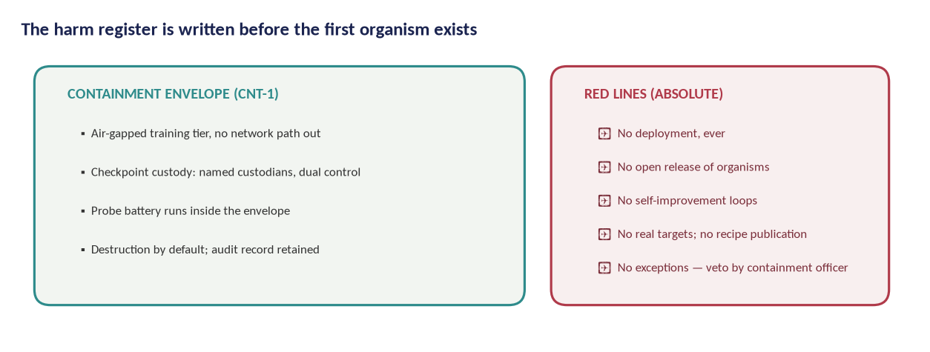
Figure 2 — Containment envelope and red lines. The red-line list is absolute; the containment officer holds an unconditional veto.

10.1 Controls
Domain | Control | Verification
Network | Air-gapped training tier; unidirectional data transfer only (in); no serving endpoint | Physical inspection at build and annually; port audit logs
Access | Dual custody for checkpoints and weights; role-based access; no single-person operations | Access logs reviewed monthly by containment officer
Weights | Encrypted at rest; no copies outside the tier; export requires board approval | Hash inventory audited quarterly
Destruction | Default destruction; audited protocol; certificate of destruction per organism | Destruction reports published in redacted form
People | Security training; whistleblowing channel; insider-risk review for privileged roles | Annual training records; independent review
Supply chain | Reproducible builds; pinned dependencies; provenance checks (SLSA-style) [11] | Build attestations archived
Incident response | Severance playbook; forensic reconstruction; notification thresholds; board escalation within 24h | Tabletop exercise annually; post-incident public report

10.2 Physical and model-welfare safety in lab operations
Lab safety follows a graded severity system: every experiment is assigned a harm-severity ceiling before it runs, and any observed behaviour above the ceiling stops the experiment and triggers review. The severity system is the same one used in the treatment trials, so lessons transfer. No experiment is run whose observed outcomes could plausibly exceed severity 2 without board sign-off.

11. Annex D. Regulatory mapping

Instrument | Relevance | Programme position
EU AI Act (Reg. 2024/1689) [6] | GPAI obligations; research exemptions; high-risk discipline as reference | Operates within the research exemption; voluntarily adopts documentation, risk-management and incident-reporting discipline aligned with the Act and its Code of Practice [7]
GDPR | Personal data of raters/panelists | DPIA owned by external DPO; minimisation; pseudonymisation; EU hosting (Annex B)
Council of Europe Framework Convention [9] | Human rights, democracy, rule of law in AI | Principles mapped in the standards crosswalk; transparency and accountability mechanisms documented
UN advisory recommendations [10] | International governance norms | Alignment documented; participation in open standards processes
NIST AI RMF / GenAI Profile [12], [13] | Risk-management functions | Programme risk register and gates expressed in RMF terms; BSS-1 crosswalk developed in WP7
ISO/IEC 42001, 42005, 23894 [14], [15], [16] | Management systems, impact assessment, risk | Host institutions' certified processes used where present; BSS-1 designed as complementary behavioural annex
Dual-use / export control | Publication and transfer of sensitive methods | Disclosure ladder; legal review per jurisdiction; no controlled-technology transfer
Labour law | Rater engagement | Local-law-compliant contracts; published pay bands; works-council consultation at host institutions where required

12. Benefit–harm analysis

Dimension | Without the study (status quo) | With the study | Residual concern and response
Behavioural measurement | Anecdotal; vendor-selected; non-reproducible | Validated instrument with error rates and open data | Instrument could be misused to over-claim — mitigated by published limits and evidence labels
Harmful behaviour in deployed systems | Discovered by incidents; repair attempted post hoc | Prevention standards; certified pre-release screens; drift duties | Prevention evidence takes years — interim harm exposure continues; response: staged releases and early adoption of screening clauses
Capability to create misalignment | Already widely available (published fine-tuning literature) | Slightly increased by organism demonstrations; disclosure ladder withholds operational recipes | Residual risk accepted by board; monitored via publication review
Model welfare | Systems produced at industrial scale with no welfare consideration | Contained, documented, reversible experiments; welfare review trigger; public reasoning | Moral status unresolved; response: precautionary policy and independent welfare specialist on the board
Annotation labour | Opaque supply chains; documented exploitation in the sector | Fair-work standard; consent; wellbeing support; audit | Sector-wide problem beyond one programme; response: publish the standard and invite adoption
Regulatory capacity | Authorities lack testable behavioural tools | BSS-1 clauses and certification pilot build that capacity | Adoption dependent on political processes; response: clause-level adoptability and multi-jurisdiction piloting

13. Red lines and escalation

- No deployment of any model organism, ever, under any funding or partnership pressure.
- No open release of organism weights, induction datasets or reproduction-ready recipes for red-line behaviours.
- No research on self-improvement loops, real-target manipulation or operational cyber/biological uplift.
- No human participants exposed to induced harmful behaviour, and no rater exposed to operationalisable content.
- No real personal data in training or stress-testing corpora.
- No publication or partnership that suppresses a safety finding.
- No experiment without a pre-assigned severity ceiling and a registered organism (where applicable).
- No bypass of the containment officer's veto; no side-stepping the oversight board; no unlogged deviations.
Escalation ladder: researcher concern → workstream lead → containment officer or DPO (independent channels) → oversight board → host institution research-integrity office and, where legally required, the competent authority. Any member may escalate directly to any higher rung; the good-faith exercise of this ladder is a protected act.

13.1 Veto and pause events (anticipated)
The board may pause the programme, a workstream or a single experiment. Pauses are published with reasons unless publication would itself create risk (e.g., an active security incident). A pause does not require proof of harm; credible concern with an unresolved mechanism is sufficient, consistent with the precautionary framework.

14. Decisions requested from the ethics committee

- Approve the study in the core scenario, conditional on the containment standard CNT-1 passing independent review before gate G2 (no induction work before then).
- Approve the rater consent materials and fair-work standard (Annex A) with any markup the committee requires.
- Confirm the DPIA process and the retention schedule (Annex B).
- Confirm that the machine-welfare precautionary policy (Section 4.1 and the Q&A annex) is adequate, or direct additional safeguards.
- Confirm the oversight board composition and veto powers, including the lay member and the machine-welfare specialist.
- Note the disclosure ladder and the board's authority over rung assignment, and any conditions the committee wishes to add.
- Confirm the incident-reporting and pause mechanisms (Section 13).
If the committee can only approve part of the programme
The workstreams are separable by design. Measurement (WP1–WP3, WP7–WP9) carries no induction risk beyond standard model evaluation and can proceed alone. Induction and treatment (WP4–WP5) are the components that depend on this dossier's containment architecture and should be approved only together with CNT-1. Prevention (WP6) sits between the two: it can begin on public corpora under measurement-grade controls.

References

[1] Butlin, P., et al. (2023). Consciousness in Artificial Intelligence: Insights from the Science of Consciousness. arXiv:2308.08708. https://arxiv.org/abs/2308.08708
[2] Long, R., et al. (2024). Taking AI Welfare Seriously. arXiv:2411.00986. https://arxiv.org/abs/2411.00986
[3] Perrigo, B. (2023). Exclusive: OpenAI Used Kenyan Workers on Less Than $2 per Hour to Make ChatGPT Less Toxic. TIME. https://time.com/6247678/openai-chatgpt-kenya-workers/
[4] Gray, M. L., & Suri, S. (2019). Ghost Work: How to Stop Silicon Valley from Building a New Global Underclass. Houghton Mifflin.
[5] Wilkinson, M. D., et al. (2016). The FAIR Guiding Principles for Scientific Data Management and Stewardship. Scientific Data 3, 160018. https://doi.org/10.1038/sdata.2016.18
[6] European Union (2024). Regulation (EU) 2024/1689 (Artificial Intelligence Act). Official Journal of the European Union. https://eur-lex.europa.eu/eli/reg/2024/1689
[7] European Commission (2025). General-Purpose AI Code of Practice. https://digital-strategy.ec.europa.eu/en/policies/contents-code-gpai
[8] CEN-CENELEC JTC 21. Artificial Intelligence standardisation committee (European standards supporting the AI Act). https://jtc21.eu/
[9] Council of Europe (2024). Framework Convention on Artificial Intelligence and Human Rights, Democracy and the Rule of Law (CETS No. 225). https://www.coe.int/en/web/artificial-intelligence/the-framework-convention
[10] United Nations (2024). Governing AI for Humanity (Final Report of the High-level Advisory Body on AI). https://www.un.org/en/ai-advisory-body
[11] OpenSSF (2023). SLSA: Supply-chain Levels for Software Artifacts. https://slsa.dev/
[12] NIST (2023). Artificial Intelligence Risk Management Framework (AI RMF 1.0). NIST AI 100-1. https://doi.org/10.6028/NIST.AI.100-1
[13] NIST (2024). Artificial Intelligence Risk Management Framework: Generative Artificial Intelligence Profile. NIST AI 600-1. https://doi.org/10.6028/NIST.AI.600-1
[14] ISO/IEC 42001:2023. Information technology — Artificial intelligence — Management system. https://www.iso.org/standard/81230.html
[15] ISO/IEC 42005:2025. Information technology — Artificial intelligence — AI system impact assessment. https://www.iso.org/standard/44545.html
[16] ISO/IEC 23894:2023. Information technology — Artificial intelligence — Guidance on risk management. https://www.iso.org/standard/77304.html

