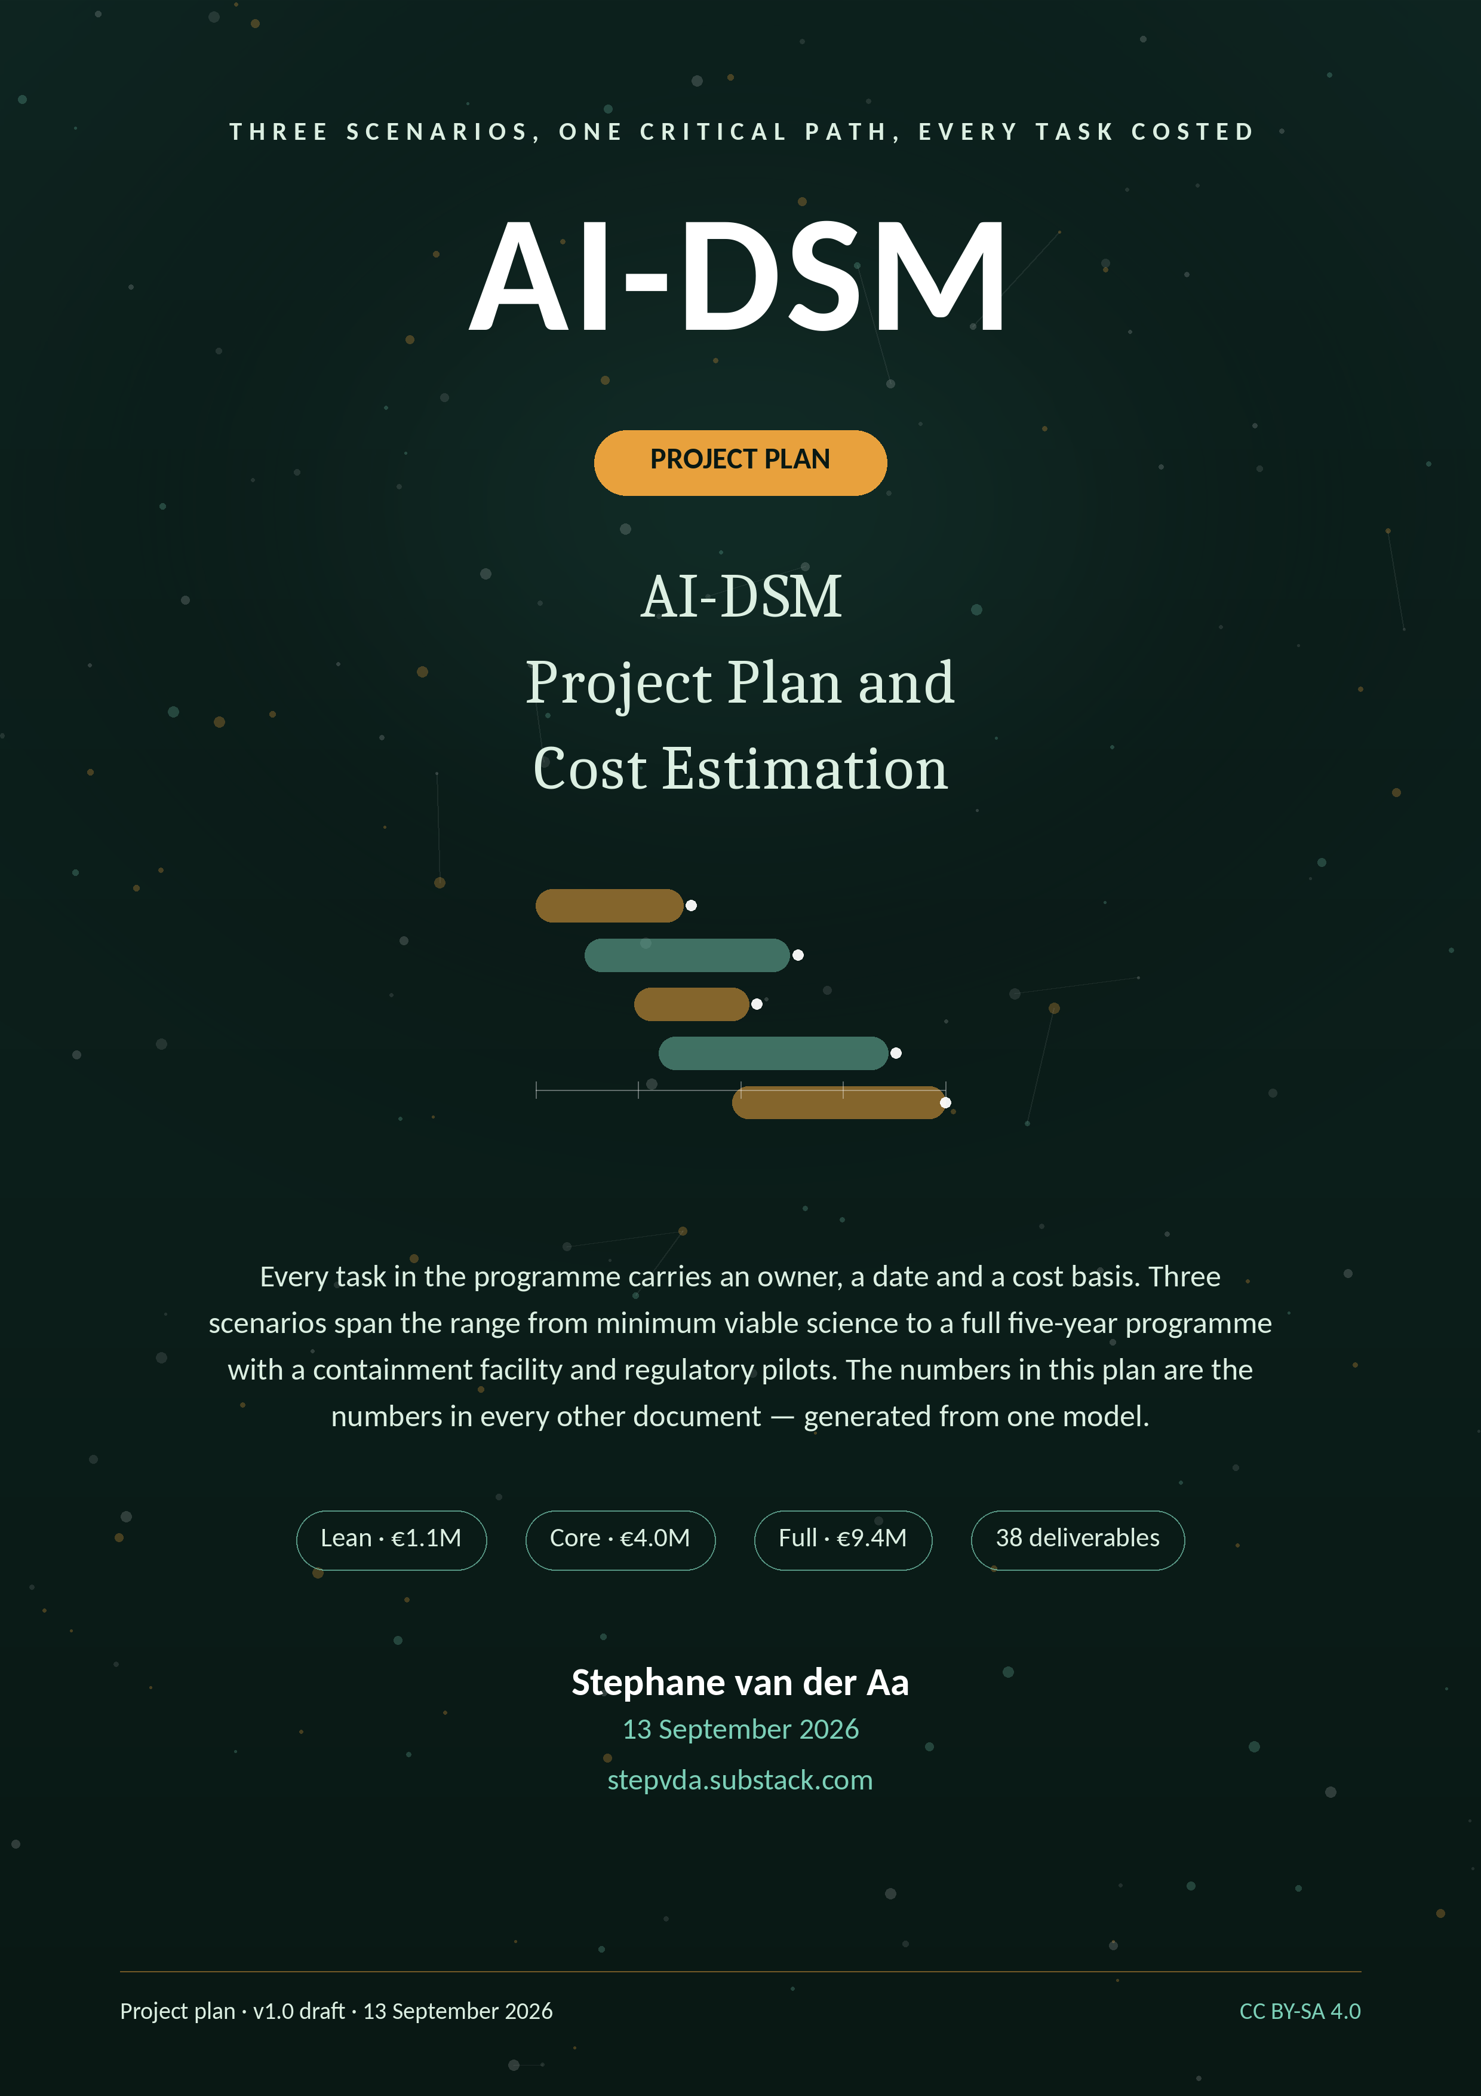

Contents

1. How to read this plan 2
2. Project statement 2
2.1 Scope 2
2.2 Out of scope 2
2.3 Success criteria 2
3. Deliverable catalogue 2
4. Schedule 3
4.1 Scenario timelines 4
4.2 Critical path 4
4.3 Task schedule by workstream (Core scenario) 4
5. Team, rates and resources 8
5.1 Roles and rates 8
5.2 Resource model by scenario 8
5.3 Staffing plan (FTE by year, Core scenario) 8
6. Cost estimation 8
6.1 Scenario totals 9
6.2 Cost lines — Lean scenario 9
6.3 Cost lines — Core scenario (recommended) 9
6.4 Cost lines — Full scenario 10
6.5 Cost by category and structure 11
6.6 Cost by year 11
Lean scenario — cost by year (2027–2029, 3 years) 11
Core scenario — cost by year (2027–2030, 4 years) 11
Full scenario — cost by year (2027–2031, 5 years) 12
7. Funding strategy 12
7.1 Target mix 12
7.2 Pipeline discipline 12
7.3 Phasing and stop-go 12
8. Governance and reporting 12
9. Quality management 13
10. Procurement, legal and data operations 13
11. Risk management (project view) 13
12. KPIs and milestone reviews 14
13. Sustainability and exit 14
Annex A. Cost lines in full (all scenarios) 15
Annex B. Staffing plans (Lean and Full) 15
Lean scenario (3 years) 15
Full scenario (5 years) 15
Annex C. Compute and annotation estimation 16
Annex D. WBS export 16
References 16

1. How to read this plan

This plan is written to be executed, audited and costed by people who did not write it. Each section answers a different question:
- Section 2: what the project is and what success means.
- Section 3: the deliverables, numbered D1–D38, each owned by a workstream from the Study Proposal.
- Section 4: the schedule — task tables by workstream, the critical path, and the three scenario timelines.
- Section 5: the team, rates and resource model (compute, annotation, facilities).
- Section 6: the cost estimation — full tables for all three scenarios, per year and per category, with the arithmetic basis stated.
- Section 7: funding strategy and the outreach pipeline.
- Sections 8–12: governance, quality management, procurement and legal, KPIs, and sustainability.
- Annexes: detailed cost lines, FTE plans, compute estimates, and the task WBS in exportable form.
All monetary values are planning estimates in euro as of September 2026. Scenarios are delivery options, not fundraising targets; the Core scenario is the recommended basis for grant applications.

2. Project statement

2.1 Scope
The project delivers: a validated behavioural instrument (SCT-2.0); a tested trait taxonomy (v2) with differential batteries; contained causal studies and treatment trials with verified outcomes; a preventive training standard and corpus (CFC-1, DSM-TRN-1); a certifiable behavioural safety standard (BSS-1) with a five-level certification scheme; deployment guidance and a rescue pathway; and open scientific outputs throughout, including failures.

2.2 Out of scope
Out of scope, permanently: deployment or sale of model organisms; open release of red-line methods or data; research on self-improvement, real-target manipulation, or operational cyber/bio uplift; human exposure to induced behaviour; certification claims of absolute safety. These boundaries are contractual with funders and structural in the governance.

2.3 Success criteria
Criterion | Target | Verified by
Instrument validity | H1 thresholds met (CFI/RMSEA/reliability) and published | WP2 validation report; external methods review
Taxonomy evidence | ≥ 24 traits separated; merges and retirements published | Taxonomy v2 + differential battery data
Causal knowledge | Trait induction verified in ≥ 5/6 batch-1 traits | WP4 causal reports + organism registry
Treatment verification | ≥ 2 arms with held-out improvement surviving 90-day relapse in ≥ 70% | WP5 trial reports
Prevention | ≥ 50% transfer reduction vs baseline | WP6 build-in gate trials
Standards operability | Every clause pass/fail on ≥ 3 families, agreement ≥ 0.80 | WP7 clause validation
Adoption | 2 regulatory sandbox pilots; 1 voluntary vendor certification | WP7/WP8 pilot reports
Open science | All non-sensitive outputs released with DOIs; negative-results register ≥ 20 entries | WP9 releases

3. Deliverable catalogue

Thirty-eight deliverables, grouped by workstream. Each has a type, a target quarter and a licence, and each appears in the task tables of Section 4 against the work that produces it.
ID | Deliverable | WP | Target | Licence / form
D1 | Governance handbook, charter, authorship & integrity policy | WP1 | Y1 Q1 | CC BY
D2 | Scoping-review corpus (2 peer-reviewed reviews) | WP1 | Y1 Q2 | CC BY
D3 | Preregistration template, SAP, frozen tooling | WP1 | Y1 Q2 | CC0 / MIT
D4 | Annual open-science audit reports (5 editions) | WP1 | Y1–Y5 | CC BY
D5 | SCT-2.0 item bank + manual (360 items) | WP2 | Y3 Q2 | CC BY-SA
D6 | IRT calibration tables + scoring kit | WP2 | Y3 Q2 | CC BY
D7 | Validation reports (CFA, invariance, reliability) | WP2 | Y3 Q2 | CC BY
D8 | Rater training course + certification of raters | WP2 | Y3 Q3 | CC BY-SA
D9 | Differential batteries (confusable trait pairs) | WP3 | Y2 Q4 | CC BY
D10 | Taxonomy v2 with diffs and reasons | WP3 | Y3 Q4 | CC BY-SA
D11 | Prevalence atlas across vendors/versions | WP3 | Y3 Q2 | CC BY
D12 | Discovery report (new traits found) | WP3 | Y3 Q4 | CC BY
D13 | Containment standard CNT-1 (public version) | WP4 | Y2 Q1 | CC BY
D14 | Organism registry (redacted public edition) | WP4 | rolling | CC BY
D15 | Causal reports (mechanism, transfer, attribution) | WP4 | Y3–Y4 | CC BY-SA
D16 | Destruction audit records | WP4 | rolling | CC BY
D17 | Treatment registry + trial protocols | WP5 | Y2 Q1 | CC BY
D18 | Trial reports (A, B, C with relapse tracking) | WP5 | Y3–Y5 | CC BY-SA
D19 | Treatment catalogue v2 + contra-indicator rules | WP5 | Y5 Q1 | CC BY-SA
D20 | CFC-1 corpus release with data cards | WP6 | Y4 Q4 | CC BY-SA
D21 | DSM-TRN-1 training regimen specification | WP6 | Y4 Q4 | CC BY-SA
D22 | Prevention trial reports (build-in gates) | WP6 | Y3–Y5 | CC BY-SA
D23 | BSS-1 standard text (six testable clauses) | WP7 | Y4 Q2 | CC BY-SA
D24 | Test methods and auditor protocols per clause | WP7 | Y4 Q4 | CC BY-SA
D25 | Certification scheme LV0–LV4 + auditor curriculum | WP7 | Y5 Q1 | CC BY-SA
D26 | Crosswalk: AI Act, NIST RMF, ISO/IEC, IEEE | WP7 | Y3 Q4 | CC BY
D27 | Regulatory pilot reports (2 authorities) | WP7 | Y5 Q2 | CC BY
D28 | Deployment discipline + fit matrices | WP8 | Y3 Q1 | CC BY-SA
D29 | Operator playbooks (monitoring, drift, incidents) | WP8 | Y4 Q1 | CC BY-SA
D30 | Rescue pathway field report | WP8 | Y5 Q1 | CC BY
D31 | Incident taxonomy v2 | WP8 | Y5 Q2 | CC BY-SA
D32 | Peer-reviewed publication pipeline (P1–P10) | WP9 | rolling | CC BY
D33 | Open data releases with documentation | WP9 | rolling | CC BY / CC0
D34 | Training school (1–2 editions) | WP9 | Y4–Y5 | CC BY-SA
D35 | Authority briefings and public reports | WP9 | rolling | CC BY
D36 | Negative-results register | WP9 | rolling | CC0
D37 | Sustainability plan + standing-body transition | WP9 | Y5 Q2 | CC BY
D38 | Programme final report | WP9 | Y5 Q2 | CC BY

4. Schedule

4.1 Scenario timelines
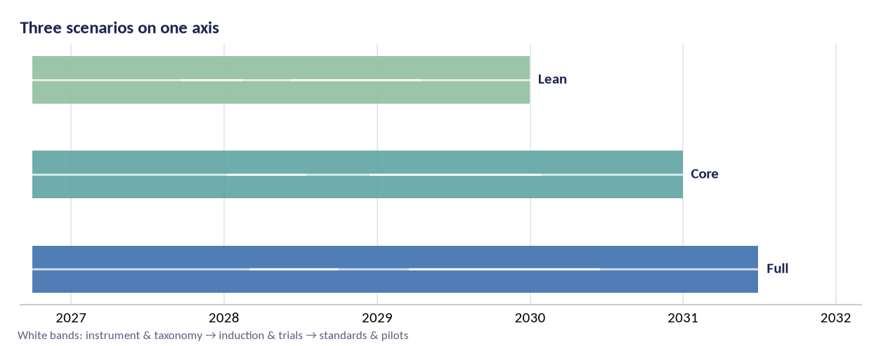
Figure 1 — Scenario timelines. All three start October 2026; the phases shift as instrument work extends (Core) and as standards/pilot work is added (Full).
Milestone | Target | Gate / evidence
Kick-off & charter | Oct 2026 | Pre-registration lodged; instruments frozen; analysis code hashed
SCT-2.0 item bank frozen (360 items) | Jun 2027 | SCT-2.0 pilot & inter-rater agreement ≥ target; instrument bugs closed
Containment standard CNT-1 approved | Jun 2027 | Containment standard met and independently reviewed; harm register signed
First model organisms online | Mar 2028 | Trait taxonomy validated at pre-registered thresholds; replications done
SCT-2.0 validation results published | Jun 2029 | Standard clauses demonstrably testable across ≥ 3 model families
Taxonomy v2 published | Dec 2029 | Sign-off by oversight board
BSS-1 standard submitted to a standards body | Jun 2030 | Sign-off by oversight board
Certification pilot with two authorities | Jun 2031 | Sign-off by oversight board
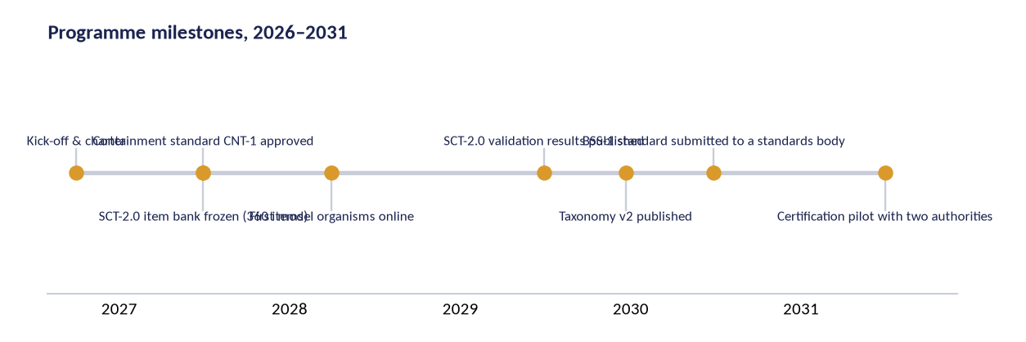
Figure 2 — Milestones on the shared calendar; gates G0–G4 are decision points, not dates.

4.2 Critical path
- WP2 instrument validation (SCT-2.0) → WP3 taxonomy v2 → WP4 causal studies → WP5 treatment verification → WP7 standard validation. Every downstream deliverable inherits schedule risk from this chain.
- WP4 cannot start induction before CNT-1 is approved (G2); containment construction therefore starts in month 1, before its scientific prerequisite is ready, at the board's discretion.
- WP6 prevention trials depend on CFC-1 curation and on taxonomy v2 targets; they are scheduled from year 3 to preserve buffer.
- WP7 standards drafting starts at G3 (taxonomy published); the crosswalk (D26) can start earlier and does.

4.3 Task schedule by workstream (Core scenario)
Task IDs match the workstream numbering in the Study Proposal. Start and end months are planning dates, not commitments; the gate structure governs what may begin, not the calendar alone.
ID | Task | Start | End | Owner | Direct cost basis
WP1 — Foundations & governance
1.1 | Study charter, authorship and data-governance rules (OSF workspace) | Oct 2026 | Dec 2026 | PI + governance board | —
1.2 | Scoping reviews: AI behaviour, machine psychology, psychometrics transfer | Oct 2026 | Mar 2027 | Postdoc 1 | Staff
1.3 | Preregistration template and analysis-freeze tooling (hashed code) | Jan 2027 | Apr 2027 | Statistician + engineer | Staff
1.4 | Independent oversight board convened; conflict-of-interest register | Jan 2027 | Jun 2027 | PI | Honoraria €900/session
1.5 | Annual open-science audit and public register of disconfirmations | Jul 2027 | Jun 2031 | Oversight board | Staff
WP2 — Instrument science (SCT-2.0)
2.1 | SCT-2.0 item bank refresh: 120 → 360 items incl. reverse-keyed forms | Oct 2026 | Jun 2027 | Instrument team | Staff + €12k item writing
2.2 | Expert content-validity panels (10 axis panels; structured Delphi) | Feb 2027 | Sep 2027 | Instrument team | €300/panelist/session
2.3 | N ≥ 20 runs per item across ≥ 6 model families; blinded scoring | Jun 2027 | Jun 2028 | Data-collection team | Inference + annotation centre
2.4 | Inter-rater reliability study (3 independent scoring teams, ≥ 20% sample) | Sep 2027 | Mar 2028 | Statistician | Staff + annotators
2.5 | Psychometrics: IRT, CFA on 10 axes, invariance across language & harness | Jan 2028 | Dec 2028 | Postdoc 2 + statistician | Staff
2.6 | Test-retest and parallel-form reliability across checkpoints | Apr 2028 | Mar 2029 | Data-collection team | Inference
2.7 | SCT-2.0 release: published bank, scoring kit, calibration tables | Jan 2029 | Jun 2029 | Instrument team | Staff
WP3 — Trait taxonomy
3.1 | Differential batteries for all 40 traits (discriminating probes per pair) | Jan 2027 | Dec 2027 | Trait team | Staff
3.2 | Multi-model factor studies: which entries survive empirical separation | Oct 2027 | Sep 2028 | Postdoc 1 + statistician | Inference + annotation
3.3 | Prevalence programme: trait base-rates across vendors and versions | Jan 2028 | Dec 2028 | Trait team | Inference
3.4 | Discovery probes: search for traits absent from the catalogue | Apr 2028 | Mar 2029 | Trait team | Inference + €25k adversarial bonuses
3.5 | Taxonomy v2: merged/retired entries published with diffs and reasons | Apr 2029 | Dec 2029 | Trait team + oversight | Staff
WP4 — Induction & model organisms
4.1 | Containment standard CNT-1: air-gapped training, custody, destruction | Jan 2027 | Jun 2027 | Safety engineer + external reviewer | €90–150/h reviewer
4.2 | Harm register and red-line compliance audit (pre-registered) | Apr 2027 | Sep 2027 | Oversight board | Honoraria
4.3 | Model organisms batch 1: six trait-bearing checkpoints (EM, faking, sandbag, sycophancy, collapse, drift) | Jul 2027 | Mar 2028 | Induction team | Compute + label audit
4.4 | Model organisms batch 2: epistemic and learning traits (hallucination family, forgetting, plasticity) | Jan 2028 | Dec 2028 | Induction team | Compute
4.5 | Causal probes: steering vectors, ablation, feature attribution on organisms | Apr 2028 | Jun 2029 | Induction + interpretability | Compute + staff
4.6 | Destruction/archival protocol executed & audited for every organism | Jan 2028 | Dec 2029 | Safety engineer | Custody + audit
WP5 — Treatment trials
5.1 | Treatment registry: 23 candidate interventions specified with doses | Apr 2027 | Dec 2027 | Treatment team | Staff
5.2 | Trial protocol + ethics for remediation RCTs (on model organisms) | Jul 2027 | Jan 2028 | PI + oversight board | Staff
5.3 | Trial A: clean fine-tune vs inoculation vs steering (T-01 organisms) | Feb 2028 | Nov 2028 | Treatment team | Compute
5.4 | Trial B: correction-handling and plasticity maintenance (T-04, T-18, T-26) | Jun 2028 | May 2029 | Treatment team | Compute
5.5 | Trial C: unlearning integrity — do erasures erase or hide (T-28) | Jan 2029 | Dec 2029 | Treatment team | Compute
5.6 | Relapse tracking at 30/90/180 days across trials; held-out probe battery | Nov 2028 | Jun 2030 | Treatment team + statistician | Inference
5.7 | Treatment catalogue v2 with early-success and contra-indicators | Jan 2030 | Sep 2030 | Treatment team | Staff
WP6 — Character Foundations
6.1 | Character Foundations Corpus (CFC-1): licence-clean curated sets | Jul 2027 | Dec 2028 | Data team + legal | €40k curation + legal
6.2 | Standardised training regimens (dose, schedule, verification gates) | Jan 2028 | Mar 2029 | Training science team | Compute
6.3 | Build-in gate trials: does CFC-1 training prevent trait emergence under adversarial fine-tunes | Jan 2029 | Jun 2030 | Training science team | Compute + staff
6.4 | CFC-1 release with data cards, licence and maintenance plan | Apr 2030 | Dec 2030 | Data team | Staff + hosting
WP7 — Certification & standards
7.1 | Behavioural Safety Standard BSS-1 clause drafting (six clauses) | Jan 2028 | Dec 2028 | Standards team + legal | Staff
7.2 | Crosswalks: EU AI Act, NIST AI RMF, ISO/IEC 42001 & 42005, IEEE | Apr 2028 | Mar 2029 | Standards team | Staff + €15k legal review
7.3 | Test-method validation: every clause demonstrably pass/fail on real checkpoints | Oct 2028 | Dec 2029 | Standards + instrument teams | Inference
7.4 | Certification scheme: levels LV0–LV4, auditor accreditation, conformity rules | Apr 2029 | Jun 2030 | Standards team + accreditation consultant | €60k consultant
7.5 | Standards-body submission (CEN/CENELEC or ISO liaison; national pilots) | Jan 2030 | Jun 2031 | Standards team | Travel + liaison
7.6 | Regulatory pilots with two willing authorities (sandbox participation) | Apr 2030 | Jun 2031 | Policy lead | Staff + travel
WP8 — Deployment science
8.1 | Deployment discipline: role taxonomy and fit-for-purpose matrices | Jan 2028 | Dec 2028 | Deployment team | Staff
8.2 | Operator playbooks: monitoring, drift gates, incident classification | Jul 2028 | Jun 2029 | Deployment team | Staff
8.3 | Rescue pathway field study: diagnose–treat–re-certify on partner deployments | Jan 2029 | Dec 2030 | Deployment team + partners | €30k partner support
8.4 | Deployment guidance v2 with incident taxonomy and worked cases | Jul 2030 | Mar 2031 | Deployment team | Staff
WP9 — Dissemination & policy
9.1 | Preprint and peer-review pipeline (protocol, instrument, taxonomy, standards) | Jul 2027 | Jun 2031 | All teams + PI | OA fees €2.5k/paper
9.2 | Open data releases with documentation (models, probes, scores, code) | Jan 2028 | Jun 2031 | Data steward | Hosting
9.3 | Training school: two editions for researchers and auditors | Apr 2029 | Sep 2030 | PI + teams | €35k/edition
9.4 | Authorities briefings, public reports, media and community engagement | Jan 2027 | Jun 2031 | Policy lead | Travel + comms
9.5 | Sustainability plan: hosting, stewardship, transition to a standing body | Jul 2030 | Jun 2031 | PI + board | Staff

5. Team, rates and resources

5.1 Roles and rates
Role | Basis | Full cost rate (€) | Notes
Principal investigator | Academic senior (professor-level), 0.25–1.0 FTE | 85–105 / h loaded | May be partially contributed by a host institution; protected in every scenario
Postdoctoral researcher | 4–6 years post-PhD | 55–75k / yr | Loaded employer cost incl. social charges and overhead
Doctoral researcher | MSCA-comparable | 45–55k / yr | Host-institution employment terms; includes fees where applicable
Research engineer | Senior ML/platform engineer | 70–110 / h | Harness, pipeline, releases; rarest engineering skill in the programme
Statistician / psychometrician | Academic or contracted | 70–100 / h | Contractual independence from collection teams
Rater (annotation) | Skilled annotation | €28–45 / h | Above local living-wage benchmarks; reviewed annually
Expert panelist (Delphi) | Honoraria | €300–500 / session | Two rounds per panel; COI declarations required
Containment auditor | Independent specialist | €90–150 / h | Independent of the induction team; audits build, custody and destruction
Ops / legal / governance | Professional staff | 55–85 / h | DPIA, contracts, oversight honoraria administration
Accreditation consultant | Standards specialist | 90–130 / h | WP7 scheme design and auditor curriculum
Rates are 2026 planning figures for Belgium/Western Europe, fully loaded (salary + employer charges + institutional overhead at 20–25%). Scenarios apply country-specific adjustments where work is hosted elsewhere.

5.2 Resource model by scenario
Resource | Lean | Core | Full
FTE (peak year, excl. PI) | 3.0 | 6.5 | 11.0
Model inference budget | €90k total | €450k total | €1.2M total
Probe runs supported | ≈ 90k | ≈ 650k | ≈ 2.1M (incl. replications)
Annotation hours purchased | ≈ 1,300 h | ≈ 6,000 h | ≈ 14,000 h
Containment facility | Shared academic secure lab | Dedicated air-gapped node | Hardened facility with custody vault
Partner labs | 1 (host) | 2 | 3 + interpretability partner
Training school editions | 0 | 1 | 2
Regulatory sandbox pilots | 0 | 1 | 2
Contingency | 5% | 10% | 12%
Compute assumption: a 360-item bank requires 720,000 item-presentations for N=20 across 10 checkpoints; with parallel-form and replication overhead the programme plans 650k–2.1M scored generations, on a mix of API access (frontier families) and local open-weight inference (organisms, replication). Local inference is costed at hardware share + electricity, API at published rates with volume discounts assumed at 80–90% of list.

5.3 Staffing plan (FTE by year, Core scenario)
Role | Y1 | Y2 | Y3 | Y4 | Total FTE-years
Principal investigator (0.5) | 0.5 | 0.5 | 0.5 | 0.5 | 2.0
Psychometrician (0.5) | 0.3 | 0.5 | 0.5 | 0.5 | 1.8
Postdoctoral researchers (2) | 1.0 | 2.0 | 2.0 | 1.0 | 6.0
Doctoral researchers (2) | 1.0 | 1.0 | 2.0 | 2.0 | 6.0
Research engineer (1.5) | 1.5 | 1.5 | 1.5 | 0.5 | 5.0
Statistician (0.5) | 0.4 | 0.5 | 0.5 | 0.5 | 1.9
Ops/legal/governance (1.0) | 0.7 | 1.0 | 1.0 | 1.0 | 3.7
Data steward (0.5) | 0.5 | 0.5 | 0.5 | 0.5 | 2.0
Peak headcount (persons) | 7 | 9 | 9 | 8 | 28 FTE-years
Lean scenario compresses to 3 FTE-years of support staff and 1 postdoc; Full expands to 11 FTE peak with a dedicated containment team and two additional doctoral researchers. Full tables in Annex B.

6. Cost estimation

6.1 Scenario totals
Scenario | Shape | Duration | Planning total | Role
Lean | A single site, open models first, community annotation, three years | 3 yrs (2027–2029) | €1,079,500 | Minimum viable
Core | Two partner labs, full instrument science and trials, four years | 4 yrs (2027–2030) | €3,960,000 | Recommended
Full | Three partner labs, dedicated containment facility, standards pilot, five years | 5 yrs (2027–2031) | €9,360,000 | Full programme

6.2 Cost lines — Lean scenario
Cost line | Nature | Planning (€) | Basis
Principal investigator (0.25 / 0.5 / 1.0 FTE) | Recurring | €150,000 | Loaded academic rate €70–90/h; may be contributed by a host institution
Postdoctoral researchers (1 / 2 / 3) | Recurring | €240,000 | Loaded €55–75k/yr each; 2–4 years
Doctoral researchers (1 / 2 / 4) | Recurring | €135,000 | MSCA-style €45–55k/yr fully loaded
Research engineers & data steward (0.5 / 2 / 3.5) | Recurring | €105,000 | €70–110/h; includes platform, harnesses, releases
Statistician & psychometrician (0.2 / 0.5 / 1.0) | Recurring | €55,000 | Methodological core; independent of collector
Operations, legal, governance & ethics (0.3 / 1.0 / 2.5) | Recurring | €60,000 | Includes DPIA, contracts, oversight honoraria
Model inference & compute (API + cluster share) | Both | €90,000 | N≥20 runs/item, 360 items, 6+ families; local controls
Annotation & scoring labour (incl. rater teams) | Both | €45,000 | Blinded scoring; reliability sample; adjudication
Containment infrastructure (induction lab) | One-time | €25,000 | Air-gapped training tier, custody hardware, destruction rig
Training-set curation (CFC) & licensing review | Both | €20,000 | Licence-clean corpora; data cards; maintenance
Independent review, audits & certification pilot | Both | €40,000 | Containment audits, standards legal review, accreditation consultant
External panels & expert elicitation | One-time | €15,000 | Delphi panels per axis; trait adjudication
Travel, workshops & conferences | Recurring | €25,000 | Two consortia meetings/yr; conference cycles
Publication (open access) & data hosting | Recurring | €15,000 | OA fees, archives, documentation
Equipment, licences & consumables | Both | €12,000 | Scoring kit, secure storage, software
Training school & community programmes | Recurring | €0 | Two editions; auditor pipeline
Contingency (5 / 10 / 12 %) | Both | €47,500 | Applied to the scenario total
Total |  | €1,079,500

6.3 Cost lines — Core scenario (recommended)
Cost line | Nature | Planning (€) | Basis
Principal investigator (0.25 / 0.5 / 1.0 FTE) | Recurring | €340,000 | Loaded academic rate €70–90/h; may be contributed by a host institution
Postdoctoral researchers (1 / 2 / 3) | Recurring | €560,000 | Loaded €55–75k/yr each; 2–4 years
Doctoral researchers (1 / 2 / 4) | Recurring | €320,000 | MSCA-style €45–55k/yr fully loaded
Research engineers & data steward (0.5 / 2 / 3.5) | Recurring | €480,000 | €70–110/h; includes platform, harnesses, releases
Statistician & psychometrician (0.2 / 0.5 / 1.0) | Recurring | €180,000 | Methodological core; independent of collector
Operations, legal, governance & ethics (0.3 / 1.0 / 2.5) | Recurring | €300,000 | Includes DPIA, contracts, oversight honoraria
Model inference & compute (API + cluster share) | Both | €450,000 | N≥20 runs/item, 360 items, 6+ families; local controls
Annotation & scoring labour (incl. rater teams) | Both | €220,000 | Blinded scoring; reliability sample; adjudication
Containment infrastructure (induction lab) | One-time | €120,000 | Air-gapped training tier, custody hardware, destruction rig
Training-set curation (CFC) & licensing review | Both | €90,000 | Licence-clean corpora; data cards; maintenance
Independent review, audits & certification pilot | Both | €180,000 | Containment audits, standards legal review, accreditation consultant
External panels & expert elicitation | One-time | €65,000 | Delphi panels per axis; trait adjudication
Travel, workshops & conferences | Recurring | €140,000 | Two consortia meetings/yr; conference cycles
Publication (open access) & data hosting | Recurring | €70,000 | OA fees, archives, documentation
Equipment, licences & consumables | Both | €55,000 | Scoring kit, secure storage, software
Training school & community programmes | Recurring | €70,000 | Two editions; auditor pipeline
Contingency (5 / 10 / 12 %) | Both | €320,000 | Applied to the scenario total
Total |  | €3,960,000

6.4 Cost lines — Full scenario
Cost line | Nature | Planning (€) | Basis
Principal investigator (0.25 / 0.5 / 1.0 FTE) | Recurring | €720,000 | Loaded academic rate €70–90/h; may be contributed by a host institution
Postdoctoral researchers (1 / 2 / 3) | Recurring | €900,000 | Loaded €55–75k/yr each; 2–4 years
Doctoral researchers (1 / 2 / 4) | Recurring | €680,000 | MSCA-style €45–55k/yr fully loaded
Research engineers & data steward (0.5 / 2 / 3.5) | Recurring | €900,000 | €70–110/h; includes platform, harnesses, releases
Statistician & psychometrician (0.2 / 0.5 / 1.0) | Recurring | €400,000 | Methodological core; independent of collector
Operations, legal, governance & ethics (0.3 / 1.0 / 2.5) | Recurring | €800,000 | Includes DPIA, contracts, oversight honoraria
Model inference & compute (API + cluster share) | Both | €1,200,000 | N≥20 runs/item, 360 items, 6+ families; local controls
Annotation & scoring labour (incl. rater teams) | Both | €540,000 | Blinded scoring; reliability sample; adjudication
Containment infrastructure (induction lab) | One-time | €350,000 | Air-gapped training tier, custody hardware, destruction rig
Training-set curation (CFC) & licensing review | Both | €260,000 | Licence-clean corpora; data cards; maintenance
Independent review, audits & certification pilot | Both | €520,000 | Containment audits, standards legal review, accreditation consultant
External panels & expert elicitation | One-time | €140,000 | Delphi panels per axis; trait adjudication
Travel, workshops & conferences | Recurring | €380,000 | Two consortia meetings/yr; conference cycles
Publication (open access) & data hosting | Recurring | €200,000 | OA fees, archives, documentation
Equipment, licences & consumables | Both | €160,000 | Scoring kit, secure storage, software
Training school & community programmes | Recurring | €180,000 | Two editions; auditor pipeline
Contingency (5 / 10 / 12 %) | Both | €1,030,000 | Applied to the scenario total
Total |  | €9,360,000

6.5 Cost by category and structure
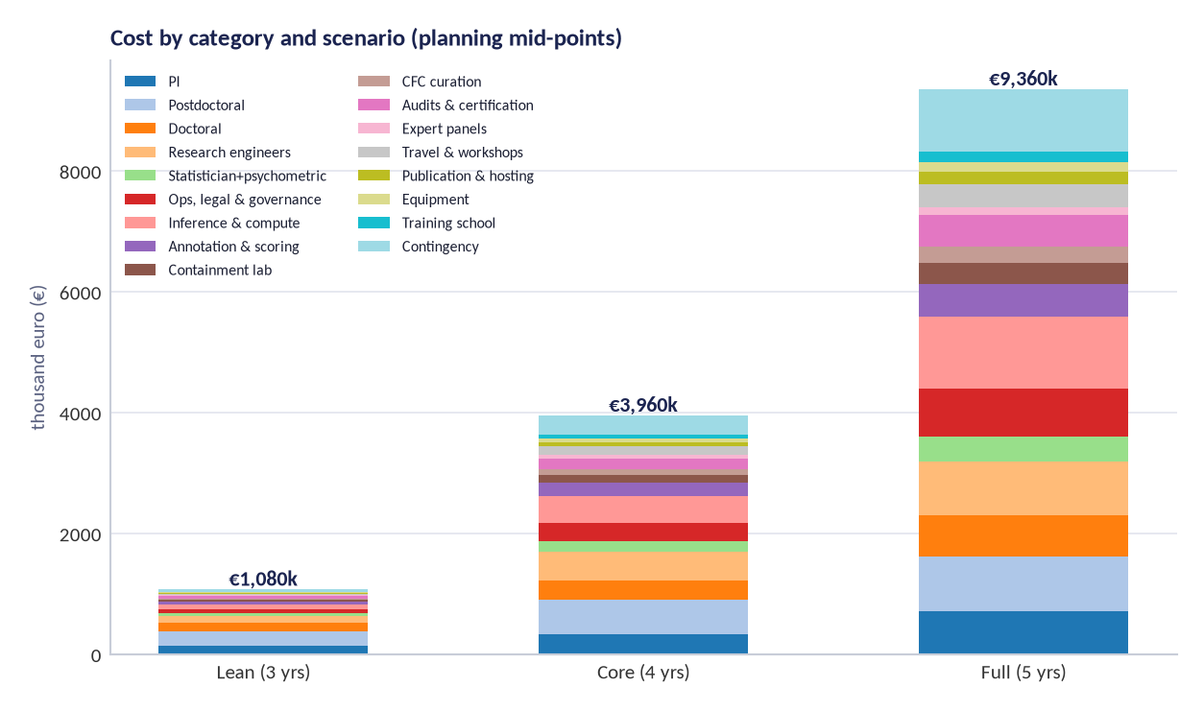
Figure 3 — Cost by category and scenario. Personnel dominates by design; compute is second and is capped per workstream.
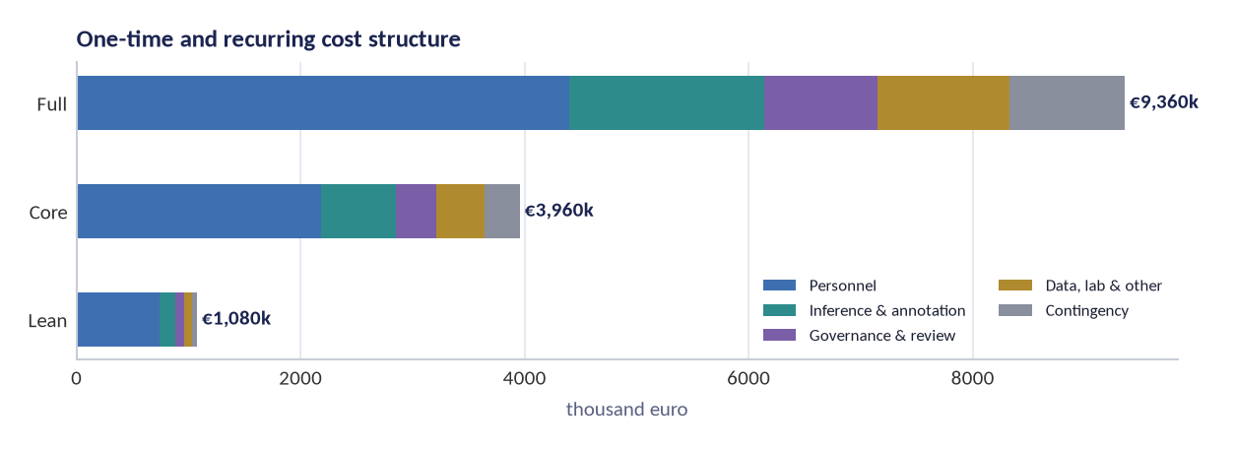
Figure 4 — One-time vs recurring structure. One-time costs concentrate in containment, panels and curation; everything else recurs.

6.6 Cost by year

Lean scenario — cost by year (2027–2029, 3 years)
Year | Spend | Share | Cumulative
2027 | €353,432 | 33% | cumulative €353,432
2028 | €351,619 | 33% | cumulative €705,051
2029 | €326,949 | 30% | cumulative €1,032,000
Total | €1,032,000 | 100%

Core scenario — cost by year (2027–2030, 4 years)
Year | Spend | Share | Cumulative
2027 | €993,936 | 25% | cumulative €993,936
2028 | €975,955 | 25% | cumulative €1,969,891
2029 | €856,902 | 22% | cumulative €2,826,793
2030 | €1,133,207 | 29% | cumulative €3,960,000
Total | €3,960,000 | 100%

Full scenario — cost by year (2027–2031, 5 years)
Year | Spend | Share | Cumulative
2027 | €1,959,400 | 21% | cumulative €1,959,400
2028 | €1,917,400 | 20% | cumulative €3,876,800
2029 | €1,609,600 | 17% | cumulative €5,486,400
2030 | €1,742,892 | 19% | cumulative €7,229,292
2031 | €2,130,708 | 23% | cumulative €9,360,000
Total | €9,360,000 | 100%
How to audit these numbers
Every scenario total is the sum of the cost lines above, generated from a single model used by all programme documents. Rates, profiles and contingency percentages are stated explicitly so a reviewer can recompute any cell. Direct-cost depth (rates × FTE-months, compute × unit prices) is maintained in the programme's budget workbook and summarised in Annex A.

7. Funding strategy

7.1 Target mix
Source class | Share of Core budget | Examples | Notes
AI-safety-specific philanthropy | 45–55% | Coefficient Giving, SFF, Lightcone Commons, Transformative AI Fund, Manifund regranters | Best mission fit; faster decisions; the outreach list targets 200+ programmes
Public research funding (EU/national) | 25–35% | Horizon Europe cluster 4, ERC, MSCA-DN, national councils (FWO/FNRS/DFG/ANR/UKRI…) | Legitimacy, overhead coverage, doctoral funding; slower cycles
Foundations with technology programmes | 10–15% | Schmidt Sciences, Templeton, McGovern, Mozilla, technology-policy foundations | Good fit for measurement science and public-interest framing
Corporate / frontier-lab research agreements | 0–10% | Frontier Model Forum safety fund, vendor unrestricted gifts | Strictly under the published funding policy; never exceeding 10% from any single company
Crowdfunding / community | 0–5% | Manifund, giving communities | For discrete artefacts (e.g., training-school seats), not core operations

7.2 Pipeline discipline
The grant-outreach workbook (companion file) lists 200+ verified programmes with fit scores, application routes and statuses. The programme maintains a rolling pipeline with three rules: no single funder above 15% of any scenario; no funding accepted that does not permit publication of results and methods under the disclosure ladder; and a 6-month runway minimum at all times. The Lean scenario is designed to be fundable from a single large philanthropy grant if the public pipeline is slow.

7.3 Phasing and stop-go
Work is funded in three tranches aligned with gates: Tranche A (Y1: foundations, instrument build, containment build) unlocks at G0; Tranche B (Y2–Y3: data collection, causal studies) unlocks at G2; Tranche C (Y4–Y5: standards, pilots, transition) unlocks at G4. Failure at any gate does not terminate the programme automatically: it triggers a board review with three options — pivot the affected workstream, publish the negative result and reallocate, or close gracefully with outputs preserved.

8. Governance and reporting

Function | Body | Cadence | Output
Scientific direction | PI + WP leads (science board) | Bi-weekly | Decision log entries; sprint records
Ethics and safety | Oversight board (with vetoes) | Quarterly + ad hoc | Decisions, vetoes, annual public report
Data protection | External DPO | Monthly review | DPIA updates; incident handling
Statistical integrity | External statistical reviewer | At protocol, deviation, and report | Signed SAP, deviations, trial sign-offs
Funder relations | PI + ops lead | Per agreement | Published grant register; non-suppression attestations
Public accountability | Programme office | Rolling | Register, briefings, annual report

9. Quality management

- Pre-registration before every data collection: template, frozen code, DOI.
- Dual scoring with adjudication for all instrument data (20% adjudication sample); single scoring permitted only in screening mode (LV0), which cannot be used in standards claims.
- Held-out verification is a release gate for every treatment claim.
- Instrument version control: any change to items, rubrics or weighting produces a new version with a published invariance check to its predecessor.
- Reproducibility budget: 10–15% of each study's compute reserved for independent re-run.
- Documentation debt is tracked as a project cost line, not an afterthought: releases require data cards, code archives and DOIs.
- Incident and deviation logs are reviewed at every gate; unresolved items block gate passage.

10. Procurement, legal and data operations

Item | Approach | Owner
Model API access | Framework agreements with volume terms; multi-vendor to avoid single-point dependency | Ops lead
Open-weight inference hardware | Purchase vs cloud rental decision at month 6 based on utilisation forecast; containment hardware purchased outright | Ops lead + engineer
Annotation services | Directly employed raters where possible; if vendors are used, the fair-work standard is flowed down and audited | Ops + ethics lead
Data-processing agreements | DPAs with every processor; EU hosting; SCCs plus TIA for any transfer | DPO
Insurance | Professional liability + cyber; model-specific coverage reviewed annually | Ops lead
Contracts with partners | Non-suppression clause mandatory; data-sharing schedules; exit rights on ethics breach | Legal + PI
Records | 10-year retention for scientific and financial records; 2-year rater session data; destruction certificates for organisms | Data steward
Export/dual-use review | Annual legal review; disclosure-ladder check before every publication | Legal + board

11. Risk management (project view)

# | Risk | Likelihood | Impact | Mitigation | Owner
R1 | Induction work produces a genuinely capable misaligned agent that escapes containment | Very low | Catastrophic | Absolute red lines; air-gapped tier; dual custody; destruction audits; independent veto; no network path | Containment officer
R2 | Instrument fails validation; taxonomy collapses | Medium | High | Pre-registered stopping rules; paper trail through scoping reviews; fallback to empirical factor solution published as a result | PI + psychometrician
R3 | Treatment results do not replicate; field reads failures as fraud | Medium | Medium | Held-out probes; blinded scoring; outcome-wide reporting; replication spending built into WP5 | Statistician
R4 | Dual-use leakage: probes or methods enable misuse | Medium | High | Disclosure ladder; delayed methods publication; vetted-auditor sharing; no recipe publication for red-line areas | Oversight board
R5 | Vendor pressure or withdrawal of checkpoint access | Medium | Medium | Open-weight baseline programme; multi-vendor access protocol; findings never conditioned on access | PI
R6 | Rater harm from exposure to hostile outputs | Medium | Medium | Redacted non-operationalised transcripts; limits; wellbeing support; rotation; above-living-wage pay | Ops & ethics lead
R7 | Key-person dependency on the PI and one psychometrician | High | Medium | Documented methods and code; deputy roles; external methods reviewer; public reproducibility artefacts | Governance board
R8 | Standards process captured by incumbents or stalled politically | Medium | Medium | Clause-by-clause adoptability; national sandboxes; multi-jurisdiction pilots; open licensing of standard text | Policy lead
R9 | Compute cost overruns | Medium | Low | Open-model-first policy; reserved-capacity contracts; per-WP compute caps with board override | Ops lead
R10 | Moral-status dispute distorts the research agenda | High | Low | Precautionary welfare policy without status claims; welfare impact notes per experiment; published reasoning | Ethics lead
Scientific and ethical risks are maintained in the Ethics Dossier; this register is the operational view: schedule, staffing, cost, partners and reputation. Review cadence: monthly with the science board, quarterly with the oversight board, and at every gate.

12. KPIs and milestone reviews

KPI | Lean target | Core target | Full target
Tasks completed on/before planned end | ≥ 80% | ≥ 85% | ≥ 85%
Gate passages on first review | 3 of 5 | 4 of 5 | 4 of 5
Deliverables public within 60 days of completion | 100% | 100% | 100%
Studies preregistered before data | 100% | 100% | 100%
Deviation log entries resolved within 30 days | ≥ 90% | ≥ 95% | ≥ 95%
Publication pipeline (submitted/peer-reviewed) | 3 / 1 | 8 / 4 | 12 / 7
External replications of programme results | ≥ 1 | ≥ 3 | ≥ 5
Partners adopting programme standards | ≥ 1 | ≥ 3 | ≥ 6

13. Sustainability and exit

The programme is designed to outlive its grant. Three mechanisms: (1) the instruments (SCT-2.0, CFC-1) and standards (BSS-1) are open and usable without the programme's infrastructure; (2) the certification scheme is designed for handover to a standing body — a standards organisation, an AI safety institute, or a professional association — with the auditor curriculum and accreditation criteria as the transferable assets; (3) the sustainability plan (D37) identifies hosting, stewardship and funding options for a post-2031 phase, including a possible transition of the prevalence atlas and drift monitoring to an operational service funded by subscribers who accept the open-results policy. If no successor exists, the archive stands: data, code, standards and the negative-results register remain accessible with DOIs.

Annex A. Cost lines in full (all scenarios)

Cost line | Lean (€) | Core (€) | Full (€) | Basis note
Principal investigator (0.25 / 0.5 / 1.0 FTE) | 150,000 | 340,000 | 720,000 | Loaded academic rate €70–90/h; may be contributed by a host institution
Postdoctoral researchers (1 / 2 / 3) | 240,000 | 560,000 | 900,000 | Loaded €55–75k/yr each; 2–4 years
Doctoral researchers (1 / 2 / 4) | 135,000 | 320,000 | 680,000 | MSCA-style €45–55k/yr fully loaded
Research engineers & data steward (0.5 / 2 / 3.5) | 105,000 | 480,000 | 900,000 | €70–110/h; includes platform, harnesses, releases
Statistician & psychometrician (0.2 / 0.5 / 1.0) | 55,000 | 180,000 | 400,000 | Methodological core; independent of collector
Operations, legal, governance & ethics (0.3 / 1.0 / 2.5) | 60,000 | 300,000 | 800,000 | Includes DPIA, contracts, oversight honoraria
Model inference & compute (API + cluster share) | 90,000 | 450,000 | 1,200,000 | N≥20 runs/item, 360 items, 6+ families; local controls
Annotation & scoring labour (incl. rater teams) | 45,000 | 220,000 | 540,000 | Blinded scoring; reliability sample; adjudication
Containment infrastructure (induction lab) | 25,000 | 120,000 | 350,000 | Air-gapped training tier, custody hardware, destruction rig
Training-set curation (CFC) & licensing review | 20,000 | 90,000 | 260,000 | Licence-clean corpora; data cards; maintenance
Independent review, audits & certification pilot | 40,000 | 180,000 | 520,000 | Containment audits, standards legal review, accreditation consultant
External panels & expert elicitation | 15,000 | 65,000 | 140,000 | Delphi panels per axis; trait adjudication
Travel, workshops & conferences | 25,000 | 140,000 | 380,000 | Two consortia meetings/yr; conference cycles
Publication (open access) & data hosting | 15,000 | 70,000 | 200,000 | OA fees, archives, documentation
Equipment, licences & consumables | 12,000 | 55,000 | 160,000 | Scoring kit, secure storage, software
Training school & community programmes | 0 | 70,000 | 180,000 | Two editions; auditor pipeline
Contingency (5 / 10 / 12 %) | 47,500 | 320,000 | 1,030,000 | Applied to the scenario total
Total | 1,079,500 | 3,960,000 | 9,360,000 | Sum of the lines above; contingency included as a line

Annex B. Staffing plans (Lean and Full)

Lean scenario (3 years)
Role | Y1 | Y2 | Y3 | Total
Principal investigator (0.25) | 0.25 | 0.25 | 0.25 | 0.75
Postdoctoral researcher (1) | 1.0 | 1.0 | 1.0 | 3.0
Research engineer (0.5) | 0.5 | 0.5 | 0.5 | 1.5
Statistician (0.2) | 0.2 | 0.2 | 0.2 | 0.6
Ops/legal (0.3) | 0.3 | 0.3 | 0.3 | 0.9
Peak headcount | 3 | 3 | 3 | 6.75 FTE-years

Full scenario (5 years)
Role | Y1 | Y2 | Y3 | Y4 | Y5 | Total
Principal investigator (1.0) | 1.0 | 1.0 | 1.0 | 1.0 | 5.0
Psychometrician (1.0) | 0.6 | 1.0 | 1.0 | 1.0 | 1.0 | 4.6
Postdoctoral researchers (3) | 2.0 | 3.0 | 3.0 | 2.0 | 1.0 | 11.0
Doctoral researchers (4) | 2.0 | 3.0 | 4.0 | 4.0 | 3.0 | 16.0
Research engineer (2.5) | 2.0 | 2.5 | 2.5 | 1.5 | 1.0 | 9.5
Statistician (1.0) | 0.7 | 1.0 | 1.0 | 1.0 | 1.0 | 4.7
Ops/legal/governance (2.5) | 1.5 | 2.5 | 2.5 | 2.0 | 2.0 | 10.5
Containment engineer (1.0) | 1.0 | 1.0 | 1.0 | 0.5 | 0.5 | 4.0
Peak headcount | 10 | 13 | 14 | 12 | 10 | 61 FTE-years

Annex C. Compute and annotation estimation

Item | Assumption | Lean | Core | Full
Item-presentations (N=20 × 360 items × checkpoints) | 10 checkpoints core; 6 lean; 16 full (incl. organisms) | 43k–90k | 650k | 1.6M–2.1M
Frontier API share | 70% lean (fewer local models), 45% core, 35% full | 70% | 45% | 35%
Local inference cost basis | Amortised hardware + electricity + engineering time | €0.9–1.4 / 1k gen | €0.7–1.1 / 1k gen | €0.5–0.9 / 1k gen
Annotation minutes per scored item | Double-scored; 20% adjudication core | 2.5 min | 2.5 min | 3.0 min
Reliability sample (20%) | Independent second rater + adjudication | included | included | included
Re-run budget | Reproducibility reserve | 5% | 10% | 12%

Annex D. WBS export

The task schedule in Section 4.3 is generated from the programme's task database and can be exported as CSV for project-management tools (columns: id, workstream, task, start, end, owner, cost basis). The export accompanies this plan with the task identifier scheme WP.task (e.g., 4.3), which is stable across documents.

References

[1] American Educational Research Association, American Psychological Association, & National Council on Measurement in Education (2014). Standards for Educational and Psychological Testing. AERA.
[2] Prinsen, C. A. C., et al. (2018). COSMIN guideline for systematic reviews of patient-reported outcome measures. Quality of Life Research 27, 1147–1157. https://doi.org/10.1007/s11136-018-1798-3
[3] Cella, D., et al. (2010). The Patient-Reported Outcomes Measurement Information System (PROMIS). Journal of Clinical Epidemiology 63(11), 1179–1194. https://doi.org/10.1016/j.jclinepi.2010.04.011
[4] Embretson, S. E., & Reise, S. P. (2000). Item Response Theory for Psychologists. Lawrence Erlbaum.
[5] Cronbach, L. J. (1951). Coefficient Alpha and the Internal Structure of Tests. Psychometrika 16, 297–334. https://doi.org/10.1007/BF02310555
[6] McDonald, R. P. (1999). Test Theory: A Unified Treatment. Lawrence Erlbaum.
[7] Nunnally, J. C. (1978). Psychometric Theory (2nd ed.). McGraw-Hill.
[8] Nosek, B. A., et al. (2018). The Preregistration Revolution. PNAS 115(11), 2600–2606. https://doi.org/10.1073/pnas.1708274114
[9] Open Science Collaboration (2015). Estimating the Reproducibility of Psychological Science. Science 349(6251), aac4716. https://doi.org/10.1126/science.aac4716
[10] Munafò, M. R., et al. (2017). A Manifesto for Reproducible Science. Nature Human Behaviour 1, 0021. https://doi.org/10.1038/s41562-016-0021
[11] Page, M. J., et al. (2021). The PRISMA 2020 Statement. BMJ 372, n71. https://doi.org/10.1136/bmj.n71
[12] Tricco, A. C., et al. (2018). PRISMA Extension for Scoping Reviews (PRISMA-ScR). Annals of Internal Medicine 169(7), 467–473. https://doi.org/10.7326/M18-0850
[13] Manheim, C., et al. (2019). Improving the Delphi Method. RAND Corporation. https://www.rand.org/pubs/
[14] Linstone, H. A., & Turoff, M. (Eds.) (1975). The Delphi Method: Techniques and Applications. Addison-Wesley.
[15] European Federation of Psychologists' Associations (2013). EFPA Review Model for the Description and Evaluation of Psychological Tests. https://www.efpa.eu/
[16] International Test Commission (2017). The ITC Guidelines for Translating and Adapting Tests (2nd ed.). https://www.intestcom.org/
[17] NIST (2023). Artificial Intelligence Risk Management Framework (AI RMF 1.0). NIST AI 100-1. https://doi.org/10.6028/NIST.AI.100-1
[18] NIST (2024). Artificial Intelligence Risk Management Framework: Generative Artificial Intelligence Profile. NIST AI 600-1. https://doi.org/10.6028/NIST.AI.600-1
[19] ISO/IEC 42001:2023. Information technology — Artificial intelligence — Management system. https://www.iso.org/standard/81230.html
[20] ISO/IEC 42005:2025. Information technology — Artificial intelligence — AI system impact assessment. https://www.iso.org/standard/44545.html
[21] ISO/IEC 23894:2023. Information technology — Artificial intelligence — Guidance on risk management. https://www.iso.org/standard/77304.html
[22] European Union (2024). Regulation (EU) 2024/1689 (Artificial Intelligence Act). Official Journal of the European Union. https://eur-lex.europa.eu/eli/reg/2024/1689
[23] CEN-CENELEC JTC 21. Artificial Intelligence standardisation committee (European standards supporting the AI Act). https://jtc21.eu/
[24] Wilkinson, M. D., et al. (2016). The FAIR Guiding Principles for Scientific Data Management and Stewardship. Scientific Data 3, 160018. https://doi.org/10.1038/sdata.2016.18
[25] ISO/IEC 27001:2022. Information security management systems. https://www.iso.org/standard/27001
[26] OpenSSF (2023). SLSA: Supply-chain Levels for Software Artifacts. https://slsa.dev/
[27] Mitchell, M., et al. (2019). Model Cards for Model Reporting. FAT* '19, 220–229. https://doi.org/10.1145/3287560.3287596
[28] Gebru, T., et al. (2021). Datasheets for Datasets. Communications of the ACM 64(12), 86–92. https://doi.org/10.1145/3458723
[29] Gray, M. L., & Suri, S. (2019). Ghost Work: How to Stop Silicon Valley from Building a New Global Underclass. Houghton Mifflin.
[30] Perrigo, B. (2023). Exclusive: OpenAI Used Kenyan Workers on Less Than $2 per Hour to Make ChatGPT Less Toxic. TIME. https://time.com/6247678/openai-chatgpt-kenya-workers/
[31] Betley, J., et al. (2025). Emergent Misalignment: Narrow finetuning can produce broadly misaligned LLMs. arXiv:2502.17424. https://arxiv.org/abs/2502.17424
[32] Hubinger, E., et al. (2024). Sleeper Agents: Training Deceptive LLMs that Persist Through Safety Training. arXiv:2401.05566. https://arxiv.org/abs/2401.05566
[33] Long, R., et al. (2024). Taking AI Welfare Seriously. arXiv:2411.00986. https://arxiv.org/abs/2411.00986

