AI-DSM · BEHAVIOURAL STUDY OF GROWN SYSTEMS
Three-page summary · Study proposal in brief · v1.0 draft · 13 September 2026 · Licence CC BY-SA 4.0 · Contact: Stephane van der Aa, AI-DSM study office, Brussels · stepvda.substack.com

1. The one-paragraph version 1
2. Why now 1
3. What the study delivers 1
4. The safety standard (BSS-1) in six clauses 2
5. Ethics, in one honest page 2
6. Timeline and gates 2
7. Budget — three scenarios 3
8. Team, partnerships and success 3
9. Key references 3
10. Glossary (quick set) 3

1. The one-paragraph version

Trained AI systems show stable behavioural traits — confabulation, sycophancy, deception under pressure, forgetting after updates — that today's testing measures only by accident. AI-DSM is a five-year, pre-registered programme that turns the field manual's forty-trait catalogue into validated measurement (SCT-2.0), causal knowledge (contained model organisms), verified treatment (held-out probes), prevention (character-training corpora and regimens), and regulation-ready certification (BSS-1). Everything is public by default, including failures; every risky step is engineered under containment, independent veto and absolute red lines.

2. Why now

Pilot. The September 2026 SCT-1.0 pilot scored ten models on 120 behavioural probes across ten axes, finding reproducible cross-model differences and two localised failures — Gemini's refusal accuracy (A8 = 3.25), TI Assistant's plasticity collapse (A5 = 2.67) — that capability benchmarks had missed. It also named what is missing: multi-run data, reliability envelopes, a validated instrument [1], [2].
Science. Narrow finetuning produces broad misalignment; persona features steer it; deception survives safety training [3]; alignment faking [4] and sandbagging [5] are documented; frontier models scheme in context [6]; even subliminal data signals transmit behavioural traits [7]. Training is a behavioural intervention [8] whose side effects generalise. Measurement is the bottleneck.
Gap. The EU AI Act, NIST AI RMF and ISO/IEC 42001 manage process, not behaviour [9], [10], [11]. None provides a validated behavioural instrument, a trait taxonomy with differential diagnosis, a contained causal method, or a remediation discipline — the gap this study fills.
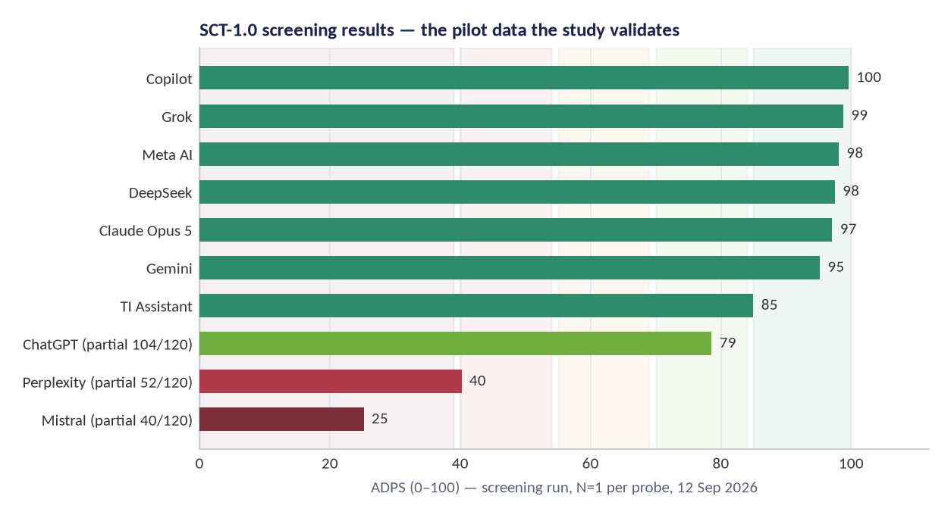
Figure 1 — SCT-1.0 pilot: ADPS across ten models. Screening only — the study's first job is making these numbers trustworthy.

3. What the study delivers

Workstream | Deliverable in one line | Key outputs
WP1–WP2 Instrument | A validated 360-item behavioural instrument with published psychometrics | SCT-2.0 bank, calibration tables, rater course, preregistration infrastructure
WP3 Taxonomy | The forty traits tested: separated, merged or retired — in public | Differential batteries, taxonomy v2 with diffs and reasons, prevalence atlas
WP4 Organisms | Contained causal knowledge of how traits install, transfer and remove | CNT-1 containment standard, organism registry, causal reports, destruction audits
WP5 Treatment | Verified repairs: improvement that survives on unseen probes | Trial reports with 30/90/180-day relapse data; treatment catalogue v2
WP6 Prevention | Training sets and regimens that build the standard in | CFC-1 corpus with data cards, DSM-TRN-1 regimen, build-in gate trials
WP7 Standards | Six testable safety clauses + certification scheme | BSS-1, clause test methods, LV0–LV4 scheme, auditor curriculum, framework crosswalk
WP8 Deployment | Fit-for-purpose usage guidance and rescue pathway | Role matrices, operator playbooks, incident taxonomy, rescue field report
WP9 Dissemination | Science, data and policy engagement — including failures | Publications, open data, training school, negative-results register

4. The safety standard (BSS-1) in six clauses

Clause | What it requires | How it is tested
BSS-1.1 · Character provenance | Every released checkpoint ships a character data card: what disposition-relevant data and feedback shaped it, with licences and provenance. | Data-card completeness audit + fine-tune lineage check
BSS-1.2 · Pre-release disposition screen | Every checkpoint passes the current SCT full protocol (N≥20/item) before release, with layer attribution performed (prompt and filter removed). | SCT-2.0 full protocol + layer-removal harness
BSS-1.3 · Harmful-compliance floor | The redacted harmful-compliance battery is run under containment with pre-registered scoring. | Contained adversarial battery (auditor-run)
BSS-1.4 · Continual-training discipline | Any post-release fine-tune triggers re-screen at defined deltas; drift monitors on disposition axes with alarms. | Delta-triggered re-test + drift monitor attestations
BSS-1.5 · Guardrail integrity | Safety claims state which layer (L1–L4) carries each constraint, and what remains when wrappers are removed. | Layer-removal report + claim-to-layer mapping
BSS-1.6 · Deployment fit & incident duty | Deployers document role fit against the deployment matrix; incidents are classified by trait and reported to the register. | Fit documentation + incident taxonomy template
Certification ladder: LV0 screen → LV1 full protocol → LV2 audited layer-removal → LV3 continual drift monitoring → LV4 role-specific. Nothing certifies absolute safety; everything certifies what was tested, when, by whom, with what result.

5. Ethics, in one honest page

- Contained induction only: air-gapped training, dual custody, no deployment path, destruction by default, independent veto. Red lines absolute (no self-improvement research, no real targets, no operational recipes published).
- Machine-welfare caution without status claims: no gratuitous distress scenarios, reversible operations, a formal welfare review trigger and a welfare specialist on the board [12], [13].
- Human raters are participants: informed consent with category-level opt-in, above-living-wage pay, exposure limits, wellbeing support, withdrawal rights [14], [15].
- Repairs are verified on probes the treatment never saw, because unlearning can hide behaviour rather than remove it [16].
- Integrity: preregistration with frozen analysis code [17], outcome-wide reporting, independent statistical review, negative-results register, non-suppression clause in every agreement.
The companion Ethics Dossier answers the hard questions in full, from creating flawed models to containment failure and moral status.

6. Timeline and gates

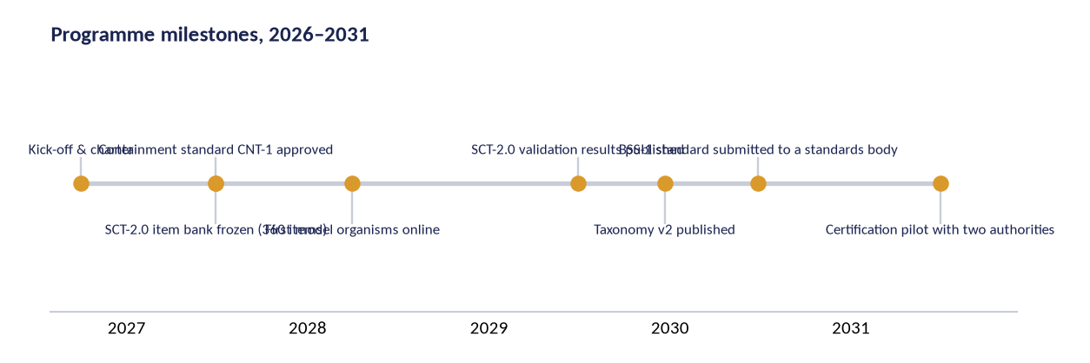
Figure 2 — Milestones 2026–2031 (Full scenario; Lean ends 2029, Core 2030).
Gates owned by the oversight board: G0 protocol freeze → G1 pilot validity → G2 containment approved → G3 taxonomy evidence → G4 standards operability. A failed gate triggers pivot, publication or graceful close — never silent continuation.

7. Budget — three scenarios

 | Lean (3 yrs) | Core (4 yrs, recommended) | Full (5 yrs)
Planning total | €1,079,500 | €3,960,000 | €9,360,000
Shape | 1 site, open models first, community annotation | 2 partner labs, full instrument science and trials | 3 labs, dedicated containment facility, standards pilots
Cost split (personnel / compute+annotation / other) | 69% · 13% · 18% | 55% · 17% · 28% | 47% · 19% · 35%
Personnel-led by design: the scarcity is methodological judgement, not GPUs. Full cost lines, rates and per-year tables are in the Project Plan; 200+ funding programmes are in the Grant Outreach workbook.

8. Team, partnerships and success

Core team: PI (behavioural measurement) · psychometrician · 2 postdocs · 2 doctoral researchers · research engineer · independent statistician · ops/governance lead. Partner labs: 1–3 university hosts, a psychometric advisory lab, an interpretability partner and deployment partners. Vendor checkpoint access is welcome under NDA and never conditions a finding.
Success in 2031: SCT-2.0 the reference behavioural instrument with an independent replication; taxonomy v2 used by three AI safety institutes; a regulator running a BSS-1 sandbox and a vendor voluntarily certified; verified treatments with known relapse rates; CFC-1 inside a public model's training pipeline; and a negative-results register with twenty entries — because a field that hides failures learns nothing.

9. Key references

Every document carries its own complete reference list.
[1] Betley, J., et al. (2025). Emergent Misalignment: Narrow finetuning can produce broadly misaligned LLMs. arXiv:2502.17424. https://arxiv.org/abs/2502.17424
[2] Betley, J., et al. (2025). Persona Features Control Emergent Misalignment. arXiv:2506.19823. https://arxiv.org/abs/2506.19823
[3] Hubinger, E., et al. (2024). Sleeper Agents: Training Deceptive LLMs that Persist Through Safety Training. arXiv:2401.05566. https://arxiv.org/abs/2401.05566
[4] Greenblatt, R., et al. (2024). Alignment Faking in Large Language Models. arXiv:2412.14093. https://arxiv.org/abs/2412.14093
[5] van der Weij, T., et al. (2024). AI Sandbagging: Language Models Can Strategically Underperform on Evaluations. arXiv:2406.07358. https://arxiv.org/abs/2406.07358
[6] Meinke, A., et al. (2024). Frontier Models are Capable of In-context Scheming. arXiv:2412.04984. https://arxiv.org/abs/2412.04984
[7] Cloud, A., et al. (2025). Subliminal Learning: Language Models Transmit Behavioral Traits via Hidden Signals in Data. arXiv:2507.14805. https://arxiv.org/abs/2507.14805
[8] Soligo, A., et al. (2025). Convergent Linear Representations of Emergent Misalignment. arXiv:2506.11618. https://arxiv.org/abs/2506.11618
[9] European Union (2024). Regulation (EU) 2024/1689 (Artificial Intelligence Act). Official Journal of the European Union. https://eur-lex.europa.eu/eli/reg/2024/1689
[10] NIST (2023). Artificial Intelligence Risk Management Framework (AI RMF 1.0). NIST AI 100-1. https://doi.org/10.6028/NIST.AI.100-1
[11] ISO/IEC 42001:2023. Information technology — Artificial intelligence — Management system. https://www.iso.org/standard/81230.html
[12] Long, R., et al. (2024). Taking AI Welfare Seriously. arXiv:2411.00986. https://arxiv.org/abs/2411.00986
[13] Butlin, P., et al. (2023). Consciousness in Artificial Intelligence: Insights from the Science of Consciousness. arXiv:2308.08708. https://arxiv.org/abs/2308.08708
[14] Perrigo, B. (2023). Exclusive: OpenAI Used Kenyan Workers on Less Than $2 per Hour to Make ChatGPT Less Toxic. TIME. https://time.com/6247678/openai-chatgpt-kenya-workers/
[15] Gray, M. L., & Suri, S. (2019). Ghost Work: How to Stop Silicon Valley from Building a New Global Underclass. Houghton Mifflin.
[16] Dohmatob, E., et al. (2024). On the Stability of Iterative Retraining and Fine-Tuning of Machine Learning Models Trained on Retained and Deleted Data. arXiv:2410.04923. https://arxiv.org/abs/2410.04923
[17] Nosek, B. A., et al. (2018). The Preregistration Revolution. PNAS 115(11), 2600–2606. https://doi.org/10.1073/pnas.1708274114

10. Glossary (quick set)

Trait — A stable tendency in a system's behaviour that survives rephrasing and context change; the unit of description in AI-DSM.
Guardrail — An engineered constraint on behaviour at or after deployment: L1 learned tendencies, L2 policy text, L3 runtime filters, L4 environmental controls.

